Information Retrieval Effectiveness of Folksonomies
on the World Wide Web

A thesis submitted to the College of Communication and Information
of Kent State University in partial fulfillment of the
requirements for the degree of
Master of Science

by

P. Jason Morrison
May, 2007

Thesis written by

P. Jason Morrison

B.A., Ohio Wesleyan University, 2001

Approved by

_________________________ , Advisor

_________________________ , Director, School of Information Architecture Knowledge Management

_________________________ , Dean, College of Communication and Information (as of May 07)

TABLE OF CONTENTS

Page

TABLE OF CONTENTS iii

LIST OF FIGURES v

LIST OF TABLES vi

ACKNOWLEDGMENTS x

CHAPTER

INTRODUCTION 1
BACKGROUND 1
RESEARCH QUESTIONS 4
Hypotheses 4
LIMITATIONS 5
REVIEW OF RELATED LITERATURE 6
FOLKSONOMIES AND RELATED LITERATURE 6
HOW USERS SEARCH THE WEB 7
IR PERFORMANCE ON THE WEB 9
Measuring search engine performance 10
Overlap of search results 17
Query factors and performance 18
Other measures of performance 20
METHODOLOGY 22
INTRODUCTION 22
RESEARCH DESIGN 22
Participants 27
IR systems in this study 29
TESTING APPARATUS 33
Data Considerations 34
RESULTS 35
SEARCH QUERY CHARACTERISTICS 35
OVERLAP AND RELEVANCE OF COMMON RESULTS 37
DIFFERENCES IN INFORMATION RETRIEVAL EFFECTIVENESS 43
Measures of effectiveness 43
Statistical analysis 46
Precision 50
Recall 55
Average Precision and Recall at Different Cutoff Ranges 58
Correlation of Measures 66
PERFORMANCE FOR DIFFERENT INFORMATION NEEDS 68
Information needs across all searches 68
Categories of Information needs 70
Specific information needs 76
Conclusion 80
ADDITIONAL FACTORS EFFECTING PERFORMANCE 81
Query characteristics 81
Qualitative analysis of queries 84
Participant characteristics 87
DISCUSSION 91
RECOMMENDATIONS 91
CONCLUSIONS 93
SUGGESTIONS FOR FUTURE RESEARCH 95

APPENDIXES
A. Testing Interface and Questionnaire 97
B. Data Model 105
C. List of Participant Information Needs and Queries 106

REFERENCES 112

LIST OF FIGURES

Figure 1: Del.icio.us 2
Figure 2: Search screen from test interface 26
Figure 3: Results screen from test interface 26
Figure 4: Distribution of values, P(20) and R(20) 47
Figure 5: IR System Precision at cutoffs 1-20 59
Figure 6: IR System Recall at Cutoffs 1-20 60
Figure 7: IR System Retrieval Rate at Cutoffs 1-20 62

LIST OF TABLES

Table 1: Previous Studies 23
Table 2: Information Need Query Prompts 25
Table 3: Participant experience survey questions 28
Table 4: IR systems considered for study 30
Table 5: IR systems evaluated in the literature 32
Table 6: Query characteristics of other experimental studies 36
Table 7: Query characteristics of search engine log analysis studies 36
Table 8: Relevancy of URL by number of IR system overlap 37
Table 9: One-Way ANOVA, Relevancy by system overlap 38
Table 10: Relevancy by overlap Kruskal Wallis test 38
Table 11: Comparing overlap rates in previous studies 38
Table 12: Relevancy by search system type overlap 39
Table 13: One-way ANOVA - Number of Search System Types vs Relevancy 40
Table 14: Relevancy by system type overlap Kruskal Wallis test 40
Table 15: Search system type overlap grouped by relevancy rate – Tukey HSD 40
Table 16: Relevancy by search system type permutation 41
Table 17: One-way ANOVA - Relevancy by search system type permutation 41
Table 18: Relevancy by system type permutation Kruskal Wallis test 41
Table 19: Comparing relevancy between search system type combinations Tukey HSD 42
Table 20: Test for Normality, at cutoff 20 47
Table 21: Test for Homogeneity of Variance, by IR system type at cutoff 20. 47
Table 22: Precision(20) of the individual IR systems 50
Table 23: Precision(20) by IR system ANOVA 51
Table 24: Precision(20) by IR system Kruskal Wallis test 51
Table 25: Precision(20) for Directory, Folksonomy, and Search Engine Searches 52
Table 26: Precision(20) for Directory, Folksonomy, and Search Engine Searches ANOVA 52
Table 27: Precision(20) by IR system Kruskal Wallis test 53
Table 28: IR systems grouped by Precision(20) Tukey HSD 53
Table 29: IR systems grouped by Retrieval Rate(20) Tukey HSD 54
Table 30: Recall(20) of the individual IR systems 55
Table 31: Recall(20) by IR system ANOVA 56
Table 32: Recall(20) by IR system Kruskal Wallis test 56
Table 33: IR systems grouped by Recall(20) Tukey HSD 56
Table 34: Test for Normality at cutoff 1-5 58
Table 35: Test for Homogeneity of Variance, by IR system type at cutoff 1-5. 58
Table 36: Average Precision(1-5) Recall(1-5) and Retrieval Rate(1-5) 62
Table 37: Precision(1-5) Recall(1-5) and Retrieval Rate(1-5) by IR system ANOVA 63
Table 38: Precision(1-5) Recall(1-5) and Retrieval Rate(1-5) by IR system Kruskal Wallis test 63
Table 39: Average Precision(1-5) Recall(1-5) and Retrieval Rate(1-5) for Directory, Folksonomy, and Search Engine Searches 64
Table 40: Precision(1-5) Recall(1-5) and Retrieval Rate(1-5) by IR system ANOVA 65
Table 41: Precision(1-5) Recall(1-5) and Retrieval Rate(1-5) by IR system type Kruskal Wallis test 65
Table 42: IR systems grouped by Precision(1-5) Tukey HSD 66
Table 43: Correlation of Precision(1-5) Recall(1-5) and Retrieval Rate(1-5) 66
Table 44: Precision(1-5) Recall(1-5) and Retrieval Rate(1-5) by Information Need 68
Table 45: Precision(1-5) Recall(1-5) and Retrieval Rate(1-5) by Information Need ANOVA 69
Table 46: Precision(1-5) Recall(1-5) and Retrieval Rate(1-5) by IR system type Kruskal Wallis test 69
Table 47: Information Needs Categories and Query Prompts 70
Table 48: Precision(1-5) Recall(1-5) and Retrieval Rate(1-5) by Information Need Category and IR System Type 71
Table 49: Precision(1-5) Recall(1-5) and Retrieval Rate(1-5) by Information Need Category and IR System Type ANOVA 72
Table 50: Precision(1-5) Recall(1-5) and Retrieval Rate(1-5) by Information Need Category and IR System Type Kruskal Wallis test 72
Table 51: Information Need Category and IR System Type grouped by Precision(1-5) Tukey HSD 73
Table 52: Multiple Comparisons (Tukey HSD) of Precision(1-5) scores of IR System Types within Information Need Categories 74
Table 53: Information Need Category and IR System Type grouped by Recall(1-5) Tukey HSD 74
Table 54: Multiple Comparisons (Tukey HSD) of Precision(1-5) scores of Information Need Categories within Directory, Folksonomy, and Search Engine Searches 75
Table 55: Precision(1-5) Recall(1-5) and Retrieval Rate(1-5) by Information Need and IR System Type 76
Table 56: Precision(1-5) Recall(1-5) and Retrieval Rate(1-5) by Information Need and IR System Type ANOVA 77
Table 57: Precision(1-5) Recall(1-5) and Retrieval Rate(1-5) by Information Need and IR system type Kruskal Wallis test 78
Table 58: Multiple Comparisons (Tukey HSD) of Precision(1-5) scores of IR System Collection Methods for selected Information Needs 79
Table 59: Multiple Comparisons (Tukey HSD) of Recall(1-5) scores of IR System Collection Methods for selected Information Needs 79
Table 60: Query characteristics (1-5) 81
Table 61: Spearman's Correlations: Query characteristics and performance (1-5) 82
Table 62: Spearman's Correlations: Query characteristics and performance of folksonomy searches 83
Table 63: Participant characteristics 87
Table 64: Spearman's Correlations: Participant characteristics and performance (1-5) 88
Table 65: Partial Correlations: Participant characteristics and performance (1-5), controlling for significant query factors 89
Table 66: Spearman's Correlations: Participant experience and performance (1-5) for folksonomy, directory, and search engine searches 90

ACKNOWLEDGMENTS
The researcher would like to thank Professor David Robins for all his input and advise during the course of this study. Professors Yin Zhang and Marcia Zeng also provided valuable advice and direction.

INTRODUCTION

BACKGROUND

In the early days of the World Wide Web, users could make use of a large number of competing information retrieval systems to satisfy their information needs. These systems could largely be divided into two categories – search engines, which used automated methods to collect documents on the web and performed full-text searches, and directories, which used human experts to collect and categorize documents. As the various directories and search engines were bought and merged, became portals, and otherwise consolidated, it seemed perhaps the question of which IR system was best for the Web had been settled . Despite advertisements asking “do you Yahoo?” (Kaser, 2003), users settled on using “to google” as a verb (Quint, 2002). A small number of search engines with advanced algorithms now dominate information seeking on the Web (Sullivan, 2006), leaving others (including subject directories) behind.

Recently, however, a number of sites have begun to employ new methods to make web surfing, and web searching, a social experience. Users of social bookmarking web sites like Del.icio.us (http://del.icio.us/) are able to add web sites to a collection and “tag” them with key words. The site compiles the keywords of all users into what is called a “folksonomy” (Gordon-Murnane, 2006). Users are then able to browse or search the folksonomies in order to find documents of interest.
Figure 1: Del.icio.us
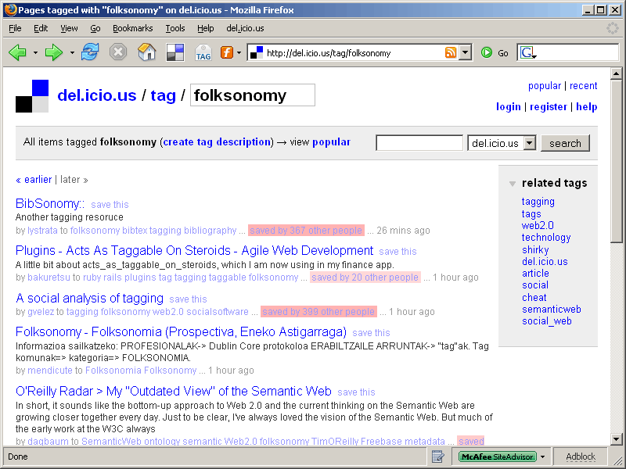
The term folksonomy invites comparisons to taxonomy. Taxonomies are systems of classification, usually describing some sort of relationship between items. The phylogenetic taxonomy of species and the Library of Congress Catalog system are examples. On the Web, this often takes the form of links to documents arranged in a hierarchical system of exclusive categories (Rosenfeld and Morville, 2002, p. 65-66). Taxonomies are often fairly static and are often compiled by experts in the subject area or in cataloging and classification. In contrast, folksonomies are “a type of distributed classification system ... usually created by a group of individuals, typically the resource users. Users add tags to online items, such as images, videos, bookmarks and text. These tags are then shared and sometimes refined” (Marieke Guy, 2006).

There has been very little academic research on the use and effectiveness of folksonomies at this point, and most academic papers have been descriptive (Dye 2006), (Fitcher 2006), (Al-Khalifa and Davis, 2006), (Cudnov et al, 2005). Many interesting topics are open to study – their function compared to traditional bookmarks, the structures of the social networks involved, the many different variations on tagging schemes and items to be tagged. In beginning empirical study of folksonomies, it is helpful to place them in the familiar context of search engines and subject directories. This study therefore examines the effectiveness or performance of systems employing folksonomies compared to more traditional web search and information organization systems for information seeking tasks.

User strategies for information seeking on the Web can be put into two categories: browsing and searching (Bodoff, 2006). Although it would be very interesting to study the effectiveness of folksonomies versus traditional, hierarchical taxonomies when users browse a catalog of Web documents, studying search performance was thought to be more straightforward. This study examines the effectiveness of systems that employ tagging to create a folksonomy in search and information retrieval (IR).

Traditionally, IR performance is measured in terms of speed, precision, and recall, and these measures can be extended to Web IR systems (Kobayashi and Takeda, 2000, p 149). Because Web search systems tend to return results very quickly and other factors, such as the speed of the user's Internet connection, would impact and performance measurements, speed is not considered.

It is important to note that Web sites that employ folksonomies are not necessarily designed to have information retrieval as the primary goal. Information retrieval is a very important function for any system of organizing information, however, so studying them in this way is worth pursuing.

RESEARCH QUESTIONS
Bearing in mind the relatively new ground explored and the importance of context, the researcher decided on two main research questions for study:

1. Do web sites that employ folksonomies return relevant results to users performing information retrieval tasks, specifically searching?
2. Do folksonomies perform as well as subject directories and search engines?

Hypotheses
Three testable hypotheses were created in order to investigate the research questions:

1. Despite different index sizes and categorization strategies, the top results from search engines, expert-maintained directories, and folksonomies will show some overlap. Items that show up in the results of more than one will be more likely to be judged relevant than those that show up in only one.
2. There will be significant difference between the IR effectiveness of search engines, expert-maintained directories, and folksonomies.
3. Folksonomies will perform as well or better than search engines and directories for information needs that fall into entertainment or current event categories. Folksonomies will perform less well for factual or specific document searches.

LIMITATIONS
One obvious drawback to this approach is that this study will not directly cover the differences in IR performance between folksonomies and taxonomies when users browse through the categories rather than searching. For example, a study could be done comparing the length of the navigation path, task completion rate and time, and other measures when browsing a conventional, hierarchical directory as opposed to a “tag cloud” with only “similar-to” or “see-also” relationships. Although such a study would be very interesting, it was believed that the current methodology would present a good first step toward evaluating the effectiveness of tagging to improve IR.

This study will not directly address many of the other ways in which users might use folksonomies and social bookmarking systems, for example browsing the newest items, looking for random items out of curiosity or for entertainment, organizing their own often-used resources, or socializing with other users. Some general questions about these topics were included in the participant questionnaire, but each of these topics deserves separate, in-depth study.

Another important limitation is one of measurement. It is not possible to truly measure the recall performance of any search against the Web as a whole, since no complete collection of Web pages exists, and it would be virtually impossible to collect all relevant Web pages for all but the most simple queries. The best measure of recall possible is the relative recall of one IR system compared to the set of all documents retrieved by all systems in the study. Precision, comparing the number of relevant documents retrieved versus the total retrieved, is a feasible measure.

REVIEW OF RELATED LITERATURE

First, the existing literature on folksonomies and related subjects such as social bookmarking, distributed classification, tagging is examined. Second, a review is made of the literature about what users are searching for on the Web. Finally this review looks at the literature on the IR performance of search engines on the Web, which were used to inform the methodology of the present study.

FOLKSONOMIES AND RELATED LITERATURE
There is no single widely-accepted definition of folksonomy, so it is important to state how the term is used in this study. The term could be used to mean an application that allows users to tag or rank items, or just the resulting organizational scheme itself. This study hopes to compare folksonomies to more traditional web search systems of information retrieval, so a broad definition is used. For the purposes of this study, folksonomy refers to IR systems where:

1. The collection is built from user contributions
2. The system of classification or ranking is built from user contributions. This is an important distinction when looking at sites like Reddit (included in this study) and Digg. In Reddit users are able to contribute “up” and “down” votes to effect the ranking of items in the collection and comment on the items but they can not tag them.
3. There is a social networking aspect to the addition, classification, or evaluation of items.

HOW USERS SEARCH THE WEB
In order to determine that a study of IR performance has external validity, it is important to look at how users search the Web and what kinds of queries users generally enter. In a 1999 study, Silverstein, Henzinger, Marais, and Moricz examined query logs from AltaVista that included over one billion queries and 285 million user sessions. The study had three key findings:
1. Users generally enter short queries;
2. Users don’t usually modify their queries; and
3. Users don’t usually look at more than the first 10 results.

Jansen, Spink, and Saracevic (2000) looked at 51,473 queries from 18,113 Excite users and had findings very similar to those of Silverstien et al. (1999). Users used generally short queries, did not look at many pages of results, and did not have many queries per session. In addition the authors found that relevance feedback and boolean operators were rarely used, and about half the time operators were used it was done incorrectly.

In addition, Spink et al (2001) looked at more than one million queries submitted by more than 200,000 users to Excite. Their findings agreed with the three points above, adding that users generally don’t use advanced search features. More than two-thirds of users submitted only one or two queries, though there was a long tail of users that submitted much larger numbers of queries. Almost half of users looked at just the first two pages of results, and the mean number of words per query was 2.4.

In addition to general Web search engines like most of those examined in the studies reviewed, many specialized search engines and single-site search engines are also available to users. Chau, Fang, and Liu Sheng (2005) looked at query logs from the Utah state government Web site. They found that searches were similar to general web searched in terms of the number of terms per query and the number of results pages viewed. On the other hand, use of query operators and term usage was different from previous studies on general Web searches.

Jansen and Spink (2006) do much better justice to this subject than this brief literature review, comparing the results of nine different large-scale search engine query log studies from 1997 through 2002. They found that for U.S. Search engines, the number of queries per session was remaining stable, with around 50% of sessions involving just one query. Query length also held mostly steady with between 20 and 29% of queries containing just one term. The use of query operators was found to be search engine dependent, with statistically significant differences between engines but not over time. The percentage of users viewing just the first results page tended to increase over time.

IR PERFORMANCE ON THE WEB
In general, studies of IR performance can be put into two categories: those that study an IR system with a defined database, and those that study IR systems that retrieve information from the Internet as a whole. Because the folksonomies under study are constructed by large numbers of users responding to their own various information organization needs, it would be impractical to construct a set database of resources and a then create a folksonomy for it. Studying existing folksonomies on the Internet is more reasonable, therefore this review will concentrate on the methodologies of that latter type of study.

There is a great deal of literature about both how users seek and search for information and how to evaluate IR systems. Greisdorf and Spink (2001) give a good overview of the various ways in which relevance can be measured in their study. By comparing 1295 relevance judgments made by 36 participants in three studies, they found when the frequency of relevance judgments is plotted on a scale from not relevant to relevant, the highest frequencies tend to be at the ends and not in the middle, whether an interval or ordinal scale was used.

A full discussion of the history of IR measurement and research is beyond the scope of this study. Instead, this review will concentrate on studies that have measured search engine IR performance.

Measuring search engine performance
Web search engines have been studied for more than a decade. In one relatively early study, Leighton and Srivastava (1999) compared the relevancy of the first 20 results from five search engines for 15 queries. Although earlier studies of search engine effectiveness exist, the authors went to lengths to describe and use a consistent, controlled methodology. One of the major advantages of their methodology was preventing relevance judges from knowing which engine a particular result came from. Attempts were also made to blind judges from the source of the documents retrieved. Another important addition, not seen in earlier studies, was testing for significance of any differences found. Results were judged by the researchers, not the original creators of the queries.

Leighton and Srivastava derived their 15 queries from 10 received at a university library reference desk along with 5 queries from another study. In order to fully test the search engines and better match normal user queries, the test queries were in natural language, making no use of Boolean or other operators.

Result documents were placed into one of six categories: inactive, duplicate, zero (irrelevant), one (relevant to query but not information need), two (relevant to query and somewhat relevant to information need), or three (widely relevant), based on Mizzaro’s (1997) framework for relevance. This was not a scale, simply a set of different categories. Overall relevance was measured by “first 20 precision,” with an added factor to account for the effectiveness of ranking. The choice of using the first 20 results and the rank weights were chosen arbitrarily, although there was some evidence that users rarely go beyond the first few pages of results. Once the data was collected, several experiments were run, varying the relevance categories used and how duplicate and inactive sites were treated.

The study found large differences in relevancy scores based on which relevance category was used, and found the best search engines performed significantly differently from the worst.

A 1999 study by Gordon and Pathak looked at eight search engines and calculated recall and precision measures to look at the overall effectives of the search engines. The design of their study improved on many earlier studies by:

1. “the elicitation of genuine information needs from genuine users,”
2. “relevance judgments made by those same individuals,”
3. “'power searches' performed for those individuals by people with specialized expertise in Web search engines who sought to maximize the performance of each search engine and”
4. “the conduct of various statistical tests of search engine effectiveness aimed at meaningfully discriminating search engine effectiveness.” (p. 142)

Gordon and Pathak (1999) found that studies of search engines fell into two categories: testimonials, which were reviews based on the experience of the reviewer along with feature lists, and shootouts, which pit several search engines directly against each other. They found that shootouts often only considered the first 10 to 20 results, fewer than were considered in many traditional information retrieval studies. They developed a framework of seven features thought to contribute toward the usefulness of such a shootout:
1) “... searches should be motivated by the genuine information needs of searchers.”
2) “... if an experiment is seeking documents on a search topic someone else has identified, that person's information need should be captured as fully and with as much context as possible. A list of keywords, even with structuring grammar (like Boolean or proximity operators) can only provide an very rough approximation of the kind of information the individual requiring information really desires.”
3) “... sufficiently large number of searches must be conducted to produce meaningful evaluations of search engine effectiveness.”
4) “... should include most major search engines.”
5) “effectiveness of different search engines must be analyzed by exploiting the special features of each engine. ...the same computer-processable query should not necessarily be used with different search engines to and Web pages for the same information need.”
6) “... relevance judgments must be made by the individual who needs the information. ... we can't emphasize enough the importance of relevance evaluations being made by those who actually require the information.”
7) “Well-conducted experiments are necessary to obtain meaningful measures of performance:
“following appropriate experimental design (for example by randomizing the order in which documents are presented to evaluators to overcome any ordering effects),”
“conforming to accepted IR measurements (like recall-precision curves) to allow results to be evaluated in a familiar context and”
“using statistical tests to measure accurately differences in performances among search engines.” (p. 146-147)

In their study, 36 faculty members were asked to fill out a five-page form with a detailed description of an existing information need. The forms were then given to expert searchers, who attempted to build the best query possible for each need (queries could vary from one engine to the next based on the features of a particular engine). The searchers then used their query to retrieve up to 200 documents. Searchers were able to modify their queries in order to get what they thought was the best result from each particular engine. The top 20 documents retrieved from each engine were printed and compiled into a booklet for the faculty members to evaluate.

The researchers took the evaluations and calculated the precision of each engine for the first 15 documents, first 16, etc. up to the first 20 and averaged the precision measurements to calculate the “average precision at document cut-off value 15-20.” A relative recall measurement was also taken, comparing the number of relevant documents retrieved by a particular engine against the total number of relevant documents for all engines. They found statistically significant differences in precision and recall at all document cut off numbers studied, with AltaVista and Open Text coming out on top and Yahoo! trailing.

A 2001 study by Hawking, Craswell, Bailey and Griffihs (2001) studied effectiveness of 20 search engines using 54 queries culled from web server logs. Hawking et al. attempted to apply methods similar to those used in studies of text-retrieval systems with static collections, specifically the TREC-8 Large Web task methodology.

Hawking et al. generally agreed with Gordon and Pathak's (1999) list of seven features, with the exception of features five and six. They found the requirement that those providing the information need evaluate the results too restrictive, and thought it would be perfectly reasonable to present the exact same query to each engine, rather than tailoring queries to match strengths. Although queries are taken from actual web logs and are therefore presumably to represent real user information needs, this study does not have access to the users that originally created the queries and does not go through an intermediate step of interpretation by expert searchers. The authors also proposed an eighth desirable feature:

8) “The search topics should represent the range of information needs both with respect to subject and to type of results wanted.”

They presented four different types of information needs based on the desired results:
1. A short factual statements that directly answers a question;
2. A specific document or web site that the user knows or suspects exists;
3. A selection of documents that pertain to an area of interest; or
4. An exhaustive list of every document that meets their need. (p. 55)

All 54 of the queries were executed against the 20 search engines. The top 20 results were recorded and presented to relevancy judges in order of document length (shortest to longest), with no indication to which document was retrieved by which engine. The actual documents were made available to judges via the text-only browser Lynx. The six judges, Australians with university degrees but no IR expertise, were asked to imagine they had submitted the query themselves and judge if each document was “on topic,” rather than assigning a degree of relevancy. All results for each query were judged by the same judge and each query was assigned to just one judge, since previous studies found no benefit to the use of multiple judges.

In general, this study found search engines performance results surprisingly consistent with Gordon and Pathak (1999). They found no significant correlation between the number of web pages indexed by an engine and the relevance of the first set of documents. For most engines, the precision decreased slowly as the number of results considered increased. In addition, they found no significant correlation between index size and performance.

Further evaluations of search engine IR performance have continued. In a study published in 2004, Can et al. devised and tested an automatic method for judging search engine performance. Because judging relevance can require the participation of many users and a large investment of time to make individual relevancy judgments, they made the assumption that documents retrieved by more than one engine were more relevant.
In their automatic Web search engine evaluation method (AWSEEM), information needs and queries were collected from participants and the top 200 results retrieved from each engine under study. The top 20 results were also given to participants to judge as relevant or not relevant. This was similar to an earlier study by Mowshowitz and Kawaguchi (2002), who used the number of search engines retrieving a particular document (by URL) as a measure of relevance. The AWSEEM method also took into account the intersection of the content of the documents retrieved. For each engine, the top 20 result documents were checked to see if they were also in the list of most similar documents overall, and if so they were judged relevant.

In this study, 19 participants (professors and students from a computer engineering department) provided detailed descriptions of 25 information needs to study. Results were pulled from eight search engines, randomized, and identifying information was removed so that the judges could not tell where a particular result came from. The participants themselves also judged the relevancy of each item in the results as either relevant or not relevant. When evaluating search engine performance, measures of both precision and relative recall were calculated.

The study found a strong, statistically significant correlation between AWSEEM and human results when looking at the top 5 results or more for each engine.

Overlap of search results
This study examines the overlap in results between folksonomies and other Web IR systems, and a number of previous studies have looked at overlap between search engines.

Gordon and Pathak (1999) examined overlap in addition to precision and recall. They found that approximately 93% of relevant results appeared in just one search engine's result set, and that this percentage was fairly stable even at higher document cutoff values. Overlap was higher for results judged to be relevant than for all results, but low in either case.

Spink, Jansen, Blakely, and Koshman (2004) conducted a large-scale study of overlap in search results between four major Web search engines and one metasearch engine. Two large sets (10,316 and 12,570 queries) were randomly selected from user-entered queries and submitted to the search engines. Spink et al found that that majority of the results returned by a search engine on the first results page were unique to that search engine, with only 1.1% of results shared across all engines.

Overlap has even been used as a measure of relevance in itself. Can et al. (2004) and Mowshowitz and Kawaguchi (2002) both used the appearance of a URL in the results of multiple search engines as a measure of relevance.

Query factors and performance
A study of IR performance should also try to either replicate or allow normal user behaviors, especially where significant effects have been shown. The studies described above varied on their use of logical operators and search-engine specific features.

In a study by Lucas (2002), 87 college student participants each created queries on eight topics for a search engine of their choice. In addition, search experts were asked to create a query for each of these topics. Both were submitted to the engines, and the best-performing query was compared to all others to see how the use of operators related to performance. Relevancy was assigned by judges working with the researchers, using a 4-point relevancy scale by Greisdorf and Spink (2001). Two judges worked independently and results were compared.

Lucas (2002) found that operator use in queries varied widely from one topic to the next.
Comparing the best-performing query with the others, the variables with highest relevance correlation were the difference between numbers of terms in the query and the percentage of terms matching between queries on same topic. Comparing query operator use and performance between the different search engines, their results suggested that users do not often consider which operators are supported by the engine of their choice, usually resulting in worse performance.

Eastman and Jansen (2003) sampled 100 queries from the search logs of a search engine (Excite) that employed the use of query operators. They created a new set of duplicate queries with the operators removed and submitted both sets to three search engines (AOL, Google and MSN) to retrieve the top 10 results. Four independent reviewers judged the relevance of the results and then coverage, relative precision, and ranking measures were calculated. The researchers found that the use of logical operators in queries did not significantly improve IR performance overall, although results varied by engine.

Other measures of performance
One issue to consider in comparing IR systems on the web is the size of their indexes, especially when comparing search engines with billions of documents in their collections to social bookmarking systems with only tens or hundreds of thousands. Hawking et al. (2001) found no positive correlation between index size and performance. In a later study, Hawking and Robertson (2003) found that increased index size can improve search engine performance. That study used a set collection of documents and compared performance to smaller subsets of that collection, rather than live search engines indexing the web as a whole.

Precision and recall are not the only two possible measures of search engine performance or quality. Beg (2005) attempted to define and demonstrate a measure of user satisfaction with search results based on result ranking. In this measure, rather than asking participants to explicitly rank the results on a form, a number of implicit factors were observed including the order in which the participant clicked on results, the time spent examining documents in the results, and whether or no the user printed, saved, bookmarked, emailed, or copied and pasted the document. A weighted sum of the factors was compared to the ranking order generated by the search engines. If a participant did not look at a document from the results, that document was deemed irrelevant.

In Beg's study the emphasis was on defining and demonstrating the search quality measure (SQM) rather than fully evaluating search engines, but the researcher did apply 15 queries to 7 search engines and found differences in quality between these engines.

Vaughan (2004) also compared search engine performance largely in terms of the ranking of results. Vaughan also examined search engine stability, or the similarity of results returned by an engine over time. Instead of precision, the study used “quality of result ranking,” the correlation between engine ranking and human ranking. As a counterpart to recall, “ability to retrieve top ranked pages,” was calculated by comparing the result set with the set of the top 75% of site as ranked by human judges.

Vaughan created four queries and collected the top 10 results from three search engines (Google, Alta Vista and Teoma) along with their rankings in each engine. The queries were resubmitted each week for a total of 10 weeks. The 24 participants (students in an information retrieval course) each ranked the results and the final human ranking was created by a group average. The study found Google to have the highest quality of result ranking and retrieval of top ranked pages, followed by Alta Vista then Teoma. In fact, Teoma did not have a significant positive correlation with the user rankings in many cases.

METHODOLOGY

INTRODUCTION

In order to better understand the effectiveness of folksonomies at information retrieval, a shootout-style study was conducted between three different kinds of Web IR system: search engines, directories, and folksonomies.

From the literature it is clear that the design of any such study needs to address a a few key questions:
- Where do the information needs / queries come from?
- Who executes queries and makes relevancy judgments?
- How large is the study (number of queries, the number of participants, queries evaluated per participant, etc.)?
- How is relevancy measured (binary yes/no, categories, scale)?
- How are searches performed, and how are results returned (blind and randomized, or in context on the search engine itself?)
- How many results will be gathered and evaluated from each IR system?
- Which measures will be used - precision, recall, ranking, or others?

RESEARCH DESIGN
Previous studies have used a range of participants of various backgrounds as well as varying numbers of queries, search engines, and measures. In order to best answer the questions about how folksonomies compare to other ways of searching the Web, it seemed beneficial to design a study comparable to previous studies of search engines. In order to judge the first hypothesis, the study would need to be able to compare overlap of results and the likelihood that results from several search systems were relevant. Relevancy judgments would also be used to calculate precision and relative recall in order to compare the individual IR systems and system types.

Some of the studies discussed in the literature review, such as Beg (2005), used methods and measures to evaluate search engines that were very different from the other studies, so the current study is not directly comparable. The table below shows relevant information about four of the comparable studies mentioned in the literature review.
Table 1: Previous Studies
 | Leighton and Srivastava (1997) | Gordon and Pathak (1999) | Hawking et al (2001) | Can et al (2003) | The Present Study
Information Needs Provided by | Library reference desk, other studies | Faculty members | Queries from web logs | Computer Science Students and Professors | Graduate students
Queries Created by | The researchers | Skilled searchers | Queries from web logs | Same | Same
Relevance Judged by | The researchers (by consensus) | Same faculty members | Research Assistants | Same | Same
Participants | 2 | 33  Faculty members | 6 | 19 | 34
Queries created and/or judged per participant | 15 | 1 | 9 | 1 to 2 | 3 to 4
Total queries | 15 | 33 | 54 | 25 | 103
Engines tested | 5 | 8 | 20 | 8 | 8
Results evaluated per engine | 20 | 20 a. | 20 | 20 | 20
Total results evaluated per evaluator: | 1500 | 160 | 3600 | 160 or 320 | About 160
Relevancy Scale | 4 categories b. | 4-point scale | Binary | Binary | Binary
Precision Measures: | P(20), weighted groups by rank | P(1-5), P(1-10), P(5-10), P(15-20) | P(1), P(1-5), P(5) P(20) | P(10), P(20) c. | P(20), P(1-5)
Recall Measures: | none | Relative recall;  R(15-20), R(15-25), R(40-60), R(90-110), R(180-200) | none | Relative recall: R(10), R(20) c. | Relative recall:  R(20), R(1-5)
a. Relevancy of items in the top 20 results in each engine was used to evaluate the top 200 results in the other engines.
b. Converted to binary for analysis
c. P(1-10), P(1-20), R(1-10), R(1-20) used to compare human and automatic evaluation but not to compare engines

Between the arguments presented in Hawking et al. (2001) and Gordon and Pathak (1999), it was believed that the best way to generate and judge the results of queries is to have users generate the queries themselves using their own information needs so that they could best judge the relevancy of results. In addition, previous studies (Voorhees 2000) found strong correlations between different relevancy judges, so including additional judges did not seem necessary.

In order to generate a range of information needs, participants were asked to create queries that fall under the topics listed in Table 2:
Table 2: Information Need Query Prompts
 | Topic | Query Prompt | Information Need Category  (Hawking, et. al., 2001)
1. | Factual information | “Think of a factual question that you know the answer too.” | A. Short factual statements that answer a question
2. | Exact Site | “Find the home page of your current (or most recent) employer.” | B. Specific document or web site
3. | Academic Research | “Think of a topic you are doing research on, or have researched in the past.” | C. A selection of documents that pertain to an area of interest
4. | News | “Think of something that was in the news recently.”
5. | General | “Think of a topic you have searched for in the past out of curiosity.”
6. | Entertainment | “Think of something you might search for if you were looking for entertainment.”
 | - | - | D. Every document in the collection that matches the information need

Topics 1 and 2 and topics 4 and 6 were specifically chosen to test hypothesis 2. Topic 1 and topic 2 each address one of Hawking et al's (2001) information need types, with the rest falling under information needs that require a selection of relevant documents. The fourth type, the need for an exhaustive collection, would be very difficult to test on the World Wide Web and is not examined in the current study.

This study did not employ a sophisticated relevance assessment tool nor did it allow users to go back and refine their queries. The literature discussed so far shows that users generally only submit a few queries and only refine queries once or twice, so it was thought that giving users a single try at creating a query would not deviate much from normal user behavior.
Figure 2: Search screen from test interface
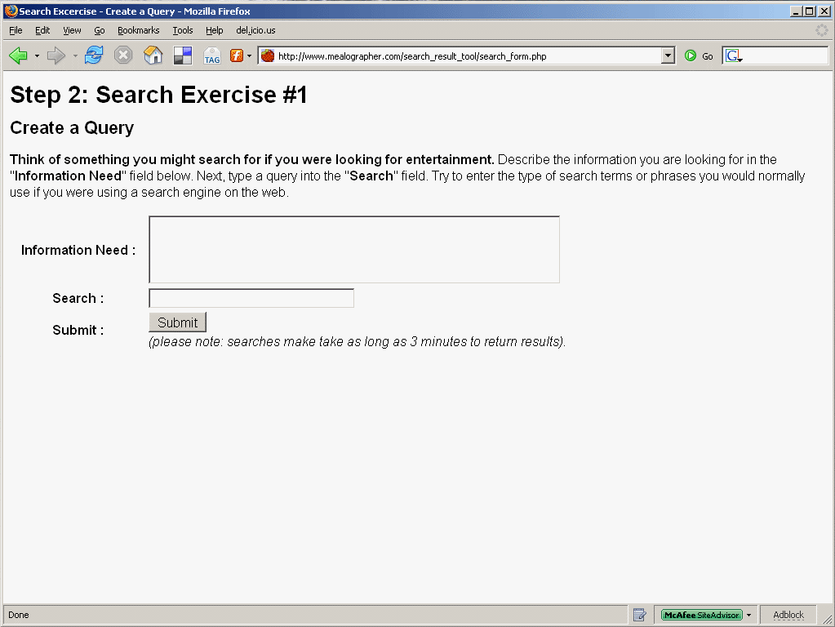
Participants both generated queries then judged the relevancy of their results. A web application was constructed to submit queries to the different IR systems, collect and randomize the results, and present the results in order to allow users to judge relevancy (see below for more details about the testing interface). Results were presented in a randomized order, with the title, description, and link to the actual site. Participants had no way to know which search engine a given result came from, and an attempt was made to present results duplicated in more than one search system just once. Figure 2 shows the search entry screen and Figure 3 shows the results screen. See Appendix A for more details abut the test interface.
Figure 3: Results screen from test interface
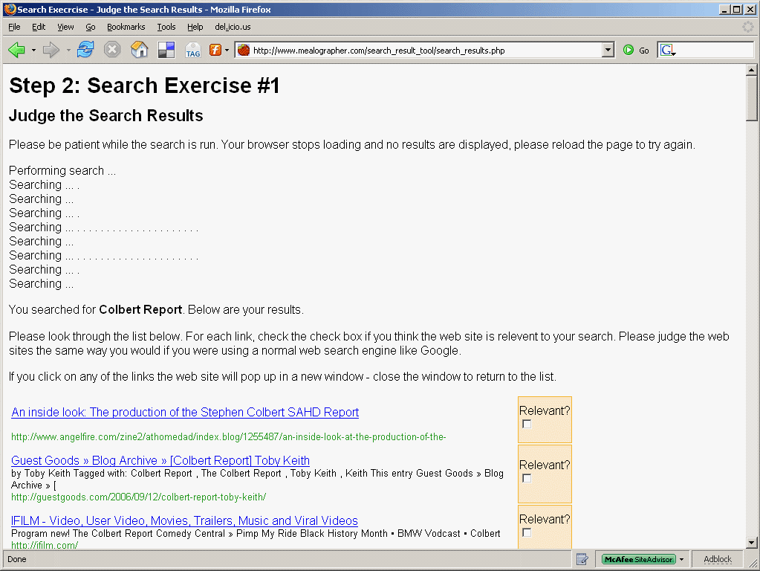
Unlike Beg (2005), the participants' actions were not observed, and this study will not examine ranking of results like Beg (2005) or Vaughan (2004). Other interesting ideas like search result stability are beyond the scope of this study.

Relevancy judgments were made on a binary, yes-or-no basis similar to the methods used in Hawking et al (2001) and Can et al. (2003).

Participants
The population from which participants in this study were drawn was all students in the Library and Information Science and Information Architecture Knowledge Management graduate programs at Kent State University. Although this population might not completely reflect all Internet users, most studies examined in the literature review have used either students or other academics to provide queries and judge relevancy. This population was the most accessible to the researcher and it was thought would provide a large enough number of participants willing to commit time to the study. Participants were solicited by an email sent to the mailing lists of each graduate program, and all participants were offered the chance to enter a drawing for one of two $100 gift cards (regardless of whether or not they completed the entire study).

Each participant was asked to create and rate the results for three queries. The query prompts were assigned randomly to each participant. Like most of the previous studies, up to 20 results were collected from each IR system for each query for the participants to rate. Silverstein et al. (1999) found that many users stop after the first set of results when searching, so retrieving more than 20 would not be in line with real-world use.

Participants were also asked to fill out a survey with questions about their experience searching and using the Web (Table 3) along with some demographic information.
Table 3: Participant experience survey questions
1) How would you rate your level of experience with the Internet and World Wide Web?
2) How would you rate your skill at finding resources online?
3) How would you rate your experience using search engines such as Google and Alta Vista?
4) How would you rate your experience using subject directories such as Yahoo Directory or the Open Directory Project?
5) How would you rate your experience using social bookmarking services such as Del.icio.us, Furl, Digg, or CiteULike?
6) How would you rate your experience using other web sites that allow you to tag items with keywords, such as Flickr or Gmail?
7) How would you rate your skill at judging web sites?

Participants were given a link to the testing interface and were able to participate in the study at their convenience from any computer with an Internet connection.

IR systems in this study
Studies in the literature review looked at as few as five and as many as 20 search engines. There are a large number of social bookmarking sites and other sites that employ tagging. Some, such as Flickr (http://www.flickr.com/), are restricted to one domain (images) and would not be easy to compare to general search engines or directories. It was considered important to restrict the number of sites under examination in order to keep the time commitment required of the participants low. Of the search systems chosen, examples of search engines, directories and social bookmarking sites with folksonomies were needed.

Table 4 shows the list of search systems considered for the study. These sites do not cover the same number of resources. Google indexes billions of pages, for example, whereas the Open Directory Project (http://www.dmoz.com/) catalogs only 4 million. Figures were harder to come by for social bookmarking sites, but there are ways to make estimates. A search of “design”, Del.icio.us's most popular tag, returned about 2900 documents. Agarwall (2006) describes a method where searches are performed for very common words, such as “the” or “a.” This method offers only an approximation, and some IR systems will either not index these terms or ignore them in queries as stop words. In addition, so of the IR systems stopped at a certain cutoff point such as 100 or 1000 results. Because of these factors size estimates were not available for all systems considered.
Table 4: IR systems considered for study
IR System | Type | Pages Indexed | Notes
Google *  http://www.google.com | Search Engine | 25.2 billion a.
MSN / Live *  http://search.msn.com/ | Search Engine | 2.5 billion a.
Alta Vista (Overture) *  http://www.altavista.com/ | Search Engine | 10 billion b.
Ask (Teoma)  http://www.ask.com | Search Engine | 4.2 billion b.
Yahoo Search  http://www.yahoo.com | Search Engine | 6.8 billion a. | Search engine results may include Yahoo Answers, etc.
Yahoo Directory *  http://dir.yahoo.com/ | Directory | unknown
Open Directory Project *  http://www.dmoz.org/ | Directory | 4 million c.
Del.icio.us *  http://del.icio.us | Social Bookmarking | 2 million b.
Furl *  http://www.furl.net | Social Bookmarking | 2 million b.
Reddit  http://www.reddit.com | Social Bookmarking | unknown  (> 1000 b.)
Digg  http://www.digg.com | Social Bookmarking | unknown | No tag search
StumbleUpon  http://www.stumbleupon.com/tag | Social Bookmarking | unknown | Results very difficult to parse
CiteULike  http://www.citeulike.org/ | Social Bookmarking | unknown  (> 1000 b.) | Focus on academic papers
Spurl.net  http://www.spurl.net/ | Social Bookmarking | unknown | No tag search
Technorati  http://www.technorati.com/ | Social Bookmarking | unknown | Limited to blog posts, photos, video
Netscape  http://www.netscape.com/ | Social Bookmarking | unknown | Focus on news
a. (Agarwall 2006)
b. Searching for “a” or “the” and taking highest result
c. As reported on site

It was important to chose systems that allowed searching of their own collections. StumbleUpon, for example, has a search interface (http://search.stumbleupon.com/) that employs Yahoo search. In order to search StumbleUpon via tags a different URL (http://www.stumbleupon.com/tag/) should be used. This search only presents 10 popular sites and 20 users who have used this tag. Similarly Furl allows a whole-web search powered by Looksmart.com. In order to search just tagged items, the user must choose “Furl” from the drop-down list.

Some of the social bookmarking sites considered were not chosen because they had restricted domains. Technorati (http://www.technorati.com/) was considered but the documents in their collection was limited to blog posts. Further studies might look at several blog search systems to see if there are distinctions between blog folksonomies like Technorati, blog search engines like Google blog search, and perhaps traditional directories of blogs.

Flickr and YouTube are very large, very popular systems that employ tagging to classify photos and videos, respectively. Because it would be difficult to find other kinds of IR systems covering the same (or similar) collections for comparison purposes, this study was limited to social bookmarking ang tagging systems that covered all Web documents.

In the end, search systems were chosen based on the following characteristics:
- Systems that were popular and in large use.
- Systems that could be easily and reliably parsed by the testing interface.
- Systems comparable to previous studies.

Google, MSN (Live), Alta Vista, Yahoo Directory, the Open Directory Project, Del.icio.us, Furl, and Reddit were chosen for this study.

It will be very difficult to directly compare results with previous studies, because many of the search engines used no longer exist, have been bought or merged into other engines, or have switched engines multiple times. Table 5 shows the IR systems covered by a number of the studies from the literature review and the present study.
Table 5: IR systems evaluated in the literature
 | Leighton and Srivastava (1997) | Gordon and Pathak (1999) | Hawking et al (2001) | Lucas (2002) | Can et al (2003) | Eastman and Jansen (2003) | Vaughan (2004) | Beg (2005) | Spink et al. (2006) | The Present Study
Alltheweb / FAST |  |  | x |  | x
Alta Vista | x | x | x | x | x |  | x | x |  | x
AOL |  |  |  | x |  | x
ANZwers |  |  | x
Ask Jeeves |  |  |  |  |  |  |  |  | x
Del.icio.us |  |  |  |  |  |  |  |  |  | x
DirectHit |  |  | x |  |  |  |  | x
EuroFerret |  |  | x
Euroseek |  |  | x
Excite | x | x | x | x |  |  |  | x
ExciteAus |  |  | x
Go |  |  |  | x
Google |  |  | x | x | y | x | x | x | x | x
Furl |  |  |  |  |  |  |  |  |  | x
HotBot | x | x | x |  | x |  |  | x
Infoseek | x | x | x |  | x
Inquirus |  |  | x
iWon |  |  |  | x
LookSmart Australia |  |  | x
Lycos | x | x | x | x | x |  |  | x
Magellan |  | x
MetaCrawler |  |  | x
Microsoft / MSN / Live |  |  | x |  | x | x |  |  | x | x
Netscape |  |  |  |  | x
Northern Light |  |  | x
Open Text |  | x
Open Directory |  |  |  |  |  |  |  |  |  | x
Reddit |  |  |  |  |  |  |  |  |  | x
Snap |  |  | x
Teoma |  |  |  |  |  |  | x
Web Wombat |  |  | x
Yahoo |  | x | x | x | y |  |  | x | x | z
x – Evaluated in study
y – At the time, Google was supplying the results for Yahoo
z – Yahoo directory results only

TESTING APPARATUS

A testing interface was developed to allow participants to submit queries, gather the results from the various IR systems, collate and randomize the results, and allow users to make binary relevance judgments. The testing interface also presented a short survey and saved all information to a database.

The interface was a public-facing Web application. Server-side code was written in PHP using the CURL library to send HTTP queries and gather responses from the IR systems under study. All data was saved in a MySQL database, and the presentation was made in XHTML and CSS to ensure compatibility with browsers.

Data Considerations

The test interface was designed to take into account situations where more than one search system returned the same web page. If a page (represented by a URL) was found in the results of the first search system, then found again in the results of the second, the entry for the second was marked with a “search_result_dupe” flag in the database and the id of the page it duplicated was saved in the field “search_result_dupe_of.”

To make analysis of the data simpler the entry for the first URL found of a set of duplicates was later updated to turn on the “search_result_dupe” flag and set the value of “search_result_dupe_of” to itself.

After the study was begun, in some searches it was found that MSN / Live reported altered URLs for the sites returned. The altered URLS had “http://g.msn.com/9SE/1?” inserted before the site URL and “&amp;&amp;” followed by a number of variables appended at the end. The entries were corrected in the database to reflect the correct URL for the web page retrieved.

Because this wasn't seen earlier, the user interface was not designed to take it into account when grouping similar results from different engines, meaning the same page would show up more than once in the results and it was possible for a participant to say that one listing was relevant and the other was not. This possibility happened in ten searches for a total of 41 URLs. Out of those 41, only 8 URLs showed an actual discrepancy in relevancy ratings. These entries were corrected to reflect the fact that they were duplicates. These 8 were corrected working under the assumption that if any of the duplicates was judged as relevant, the URL represented a relevant web site.

When analyzing the data it also became clear that in a few cases a search engine returned one web page more than once in the same result set. This occurred in 15 URLs, but in only one of those cases was there a different rating between the duplicated web pages. Since this study is examines URLs retrieved by multiple different engines, no changes were made to these entries and they were not considered duplicates in the analysis.

RESULTS
A total of 34 participants completed the study, completing 103 total searches. Each search was submitted to 8 different engines, and the top 20 results were collected for each engine, giving a possible total number of results of 16,480. For many searches, one or more of the search systems returned less than 20 results – the total number of results actually returned was 9266. Out of that number, 2021 were web pages returned multiple times in the same search, about 22% of the total.

SEARCH QUERY CHARACTERISTICS
It was important for the external validity of the results to compare queries entered by the participants with queries in other “shootout” studies and those found in studies of Web query logs. Table 6 shows some figures for the former and Table 7 the latter.
Table 6: Query characteristics of other experimental studies
 | Leighton and Srivastava (1997) | Gordon and Pathak (1999) | Hawking et al (2001) | Lucas (2002) | Can et al (2003) | Current Study
Avg words per query | 4.9 | - | 5.9 | 2.76 | 3.80 | 4.10
Operator use rate |  |  |  | 41.4%
Operators per query | 0 |  | 0 | 0.63 | 1.68 | .72
Boolean Operators per query | 0 |  | 0 | 0.16 | 1.68 | .40

Table 7: Query characteristics of search engine log analysis studies
 | (Silverstein et al., 1999) | (Jansen et al., 2000) | Spink et al (2001) | Chau et al (2005) | Current Study
Avg words per query | 2.35 | 2.21 | 2.4 | 2.25 | 4.10
Operator use rate | 20.4% | <10% (boolean) | 4% (boolean)  5% (plus) | 34.4
Operators per query | 0.41 | - | - |  | .72
Boolean Operators per query | - | - | - |  | .40
Avg queries per session | 2.02 | 2.84, 1.6 | 4.86, 2.52 unique | 1.73, 1.25 unique | 1
Avg screens examined per query | 1.39 screens | 2.35 | 8 (median) | 1.47 | 2
Percentage single-query sessions | 77.6% | 67% | 48.8% | - | 100%

OVERLAP AND RELEVANCE OF COMMON RESULTS
There are two ways a Web page, identified by a unique URL, could show up more than once in a single search: either one of the engines returned duplicate results (which happened in 16 cases), or the web page was retrieved by more than one search system. This latter case is the more interesting one. In this study Web pages showed up in the results of as many as six of the IR systems in a single search. All together, the search systems in the study returned 8076 unique web pages.

Reviewing the literature has revealed that URLs returned by more than one search engine are more likely to be relevant. Table 8 below shows that this is clearly the case in this study as well. The percentage of results deemed relevant by participants almost doubled if a web site was returned by two search systems rather than one. The rate continues to increase for web sites found by three, four, and five search systems, and a one-way ANOVA shows this to be a very strong positive correlation (See Table 9) – the F value is large, so the null hypothesis can be rejected. A nonparametric Kruskal Wallis test also shows significant differences between the groups (Table 10).
Table 8: Relevancy of URL by number of IR system overlap

Number of engines returning the URL | Number of unique results | Relevancy rate | SD
1 | 7223 | .1631 | .36947
2 | 617 | .2950 | .45640
3 | 176 | .3580 | .48077
4 | 43 | .4884 | .50578
5 | 15 | .4667 | .51640
6 | 2 | .0000 | .00000
Total | 8076 | .1797 | .38393
Table 9: One-Way ANOVA, Relevancy by system overlap
 | Sum of Squares | df | Mean Square | F | Sig.
Between Groups | 21.181 | 5 | 4.236 | 29.241 | .000
Within Groups | 1169.121 | 8070 | .145
Total | 1190.302 | 8075
Table 10: Relevancy by overlap Kruskal Wallis test
 | Relevancy rate
Chi-Square | 143.664
df | 5
Asymp. Sig. | .000

The majority, nearly 90%, of URLs only appeared in the results of one IR system. Table 11 compares the results of the current study with previous studies discussed in the literature review. Although the similar Gordon and Pathak study (1999) saw less overlap, the current study falls comfortably between those results and the results of Spink et al (2006). Overlap rates went up when only considering results that were judged to be relevant, much like Gordon and Pathak's results. These similarities point to the validity of comparing results from the directories and folksonomies as previous studies have compared just search engines.
Table 11: Comparing overlap rates in previous studies
Number of engines | Gordon and Pathak (1999), @20 |  | Spink et al (2006) | Current Study
 | All results | Relevant | All results | All results | Relevant
1 | 96.8% | 93.4% | 84.9% | 89.44% | 81.18%
2 | 2.9% | 6.0% | 11.4% | 7.64% | 12.54%
3 | 0.3% | 0.4% | 2.6% | 2.18% | 4.34%
4 | 0.1% | 0.3% | 1.1% | 0.53% | 1.45%
5 | 0.0% | 0.0% |  | 0.19% | 0.48%
6 | - | - |  | 0.02% | 0.00%
7 | - | - |  | - | -
8 | - | - |  | - | -

The analysis above does not yet give any indication of how the folksonomies' results overlapped with other IR systems. In order to answer the first hypothesis, overlap between different IR system types must be examined as well.

Is there a similarly positive effect when a web site is returned by the different types of search systems? Definitely. Table 12 below shows the percentage of web sites judged to be relevant for those found by one type of system, two types, and all three types. URLs that appeared in the results of just one type of search system were only about half as likely to be relevant as those that appeared in two types of search systems, and those that appeared in all three were even more likely. A One-way ANOVA (Table 13) and a Kruskal Wallis test (Table 14) show a strong, significant correlation.
Table 12: Relevancy by search system type overlap
Number of engine types returning the URL | Number of unique results | Relevancy Rate | SD
1 | 7877 | .1752 | .38016
2 | 173 | .3468 | .47734
3 | 26 | .4231 | .50383
Total | 8076 | .1797 | .38393

Table 13: One-way ANOVA - Number of Search System Types vs Relevancy
 | Sum of Squares | df | Mean Square | F | Sig.
Between Groups | 6.532 | 2 | 3.266 | 22.273 | .000
Within Groups | 1183.770 | 8073 | .147
Total | 1190.302 | 8075

Table 14: Relevancy by system type overlap Kruskal Wallis test
 | Relevancy rate
Chi-Square | 44.308
df | 2
Asymp. Sig. | .000

A Tukey HSD test (Table 15) shows that the differences between URLs found in one type and two or three types are significant, although the difference between two and three types was not significant. Part of the reason for this lack of significance is the small number of URLs returned by all three types, just 26.
Table 15: Search system type overlap grouped by relevancy rate – Tukey HSD
 | N | Subset for alpha = .05
Engine Types |  | 1 | 2
1 | 7877 | .1752
2 | 173 |  | .3468
3 | 26 |  | .4231
Sig. |  | 1.000 | .479

A more detailed analysis of sets where URLs were found in the different permutations of IR system type is also possible. For example, URLs found in both a search engine and a folksonomy might be different from those found in both a directory and a search engine. Table 16 displays the results of such an analysis. Web pages that were returned by all three types were most likely to be relevant (42.31%), followed closely by those returned by directories and search engines (41.79%) and those returned by folksonomies and search engines (31.91%). The web pages returned just by search engines were actually more likely to be relevant than those returned by both directories and folksonomies (23.50% to 16.67%). Statistical tests found si101gnificant differences among these groups (Table 17, Table 18).
Table 16: Relevancy by search system type permutation
Engine types returning same URL |  |  | N | Mean | Std. Deviation
Directory | Folksonomy | Search Engine
no | no | yes | 4801 | .2350 | .42401
no | yes | no | 2484 | .0676 | .25117
yes | no | no | 592 | .1419 | .34923
no | yes | yes | 94 | .3191 | .46865
yes | no | yes | 67 | .4179 | .49694
yes | yes | no | 12 | .1667 | .38925
yes | yes | yes | 26 | .4231 | .50383
 |  | Total | 8076 | .1797 | .38393

Table 17: One-way ANOVA - Relevancy by search system type permutation
 | Sum of Squares | df | Mean Square | F | Sig.
Between Groups | 53.871 | 6 | 8.978 | 63.750 | .000
Within Groups | 1136.431 | 8069 | .141
Total | 1190.302 | 8075

Table 18: Relevancy by system type permutation Kruskal Wallis test
 | Relevancy rate
Chi-Square | 365.564
df | 6
Asymp. Sig. | .000

Only 199 URLs appeared in multiple search system types, so some of the specific combinations cover a relatively small number of cases. Therefore it is not surprising that not all comparisons between groups are statistically significant. Table 19 shows the results of such a comparison, with significant comparisons highlighted.
Table 19: Comparing relevancy between search system type combinations Tukey HSD
 |  | Mean Difference (I-J) | Std. Error | Sig.
Type | Type
Search | Folks | .1673* | .00928 | .000
 | Folks & Search | -.0842 | .03908 | .321
 | Dir | .0931* | .01635 | .000
 | Dir & Search | -.1830* | .04617 | .001
 | Dir & Folks | .0683 | .10847 | .996
 | All | -.1881 | .07380 | .142
Folks | Search | -.1673* | .00928 | .000
 | Folks & Search | -.2515* | .03943 | .000
 | Dir | -.0743* | .01716 | .000
 | Dir & Search | -.3503* | .04646 | .000
 | Dir & Folks | -.0990 | .10860 | .971
 | All | -.3554* | .07398 | .000
Folks & Search | Search | .0842 | .03908 | .321
 | Folks | .2515* | .03943 | .000
 | Dir | .1773* | .04167 | .000
 | Dir & Search | -.0988 | .06000 | .652
 | Dir & Folks | .1525 | .11504 | .840
 | All | -.1039 | .08316 | .874
Dir | Search | -.0931* | .01635 | .000
 | Folks | .0743* | .01716 | .000
 | Folks & Search | -.1773* | .04167 | .000
 | Dir & Search | -.2760* | .04837 | .000
 | Dir & Folks | -.0248 | .10943 | 1.000
 | All | -.2812* | .07520 | .004
Dir & Search | Search | .1830* | .04617 | .001
 | Folks | .3503* | .04646 | .000
 | Folks & Search | .0988 | .06000 | .652
 | Dir | .2760* | .04837 | .000
 | Dir & Folks | .2512 | .11764 | .332
 | All | -.0052 | .08671 | 1.000
Dir & Folks | Search | -.0683 | .10847 | .996
 | Folks | .0990 | .10860 | .971
 | Folks & Search | -.1525 | .11504 | .840
 | Dir | .0248 | .10943 | 1.000
 | Dir & Search | -.2512 | .11764 | .332
 | All | -.2564 | .13097 | .442
All | Search | .1881 | .07380 | .142
 | Folks | .3554* | .07398 | .000
 | Folks & Search | .1039 | .08316 | .874
 | Dir | .2812* | .07520 | .004
 | Dir & Search | .0052 | .08671 | 1.000
 | Dir & Folks | .2564 | .13097 | .442
* The mean difference is significant at the .05 level.

The comparisons are quite interesting. Imagine a search engine trying to get an edge on it competitors – how could it best improve the relevancy of its results? Adding or meta-searching a folksonomy could significantly improve results. Although URLs that appeared in both directory and search engine results scored even better, the difference between that set and the folksonomy/search engine set was not statistically significant. On the other hand, incorporating a folksonomy into an existing directory might not significantly improve the relevancy of the results, at least for IR systems like those used in this study.

If these measures of comparative benefit were used as part of a cost-benefit analysis, information system owners could make informed decisions on how to improve information retrieval in their search systems. A CIO looking to improve a company intranet search system can see that adding a directory might improve IR performance by about 180 percent, and adding a folksonomy might only improve performance by about 130 percent. If the cost of creating and staffing a directory (which involves developing central control mechanisms, paying expert employees to find and classify web pages, etc.) is found to be 200 percent the cost of creating a folksonomy system (with many employees devoting tiny amounts of effort to tag or bookmark pages), then the folksonomy will have the best payoff.

DIFFERENCES IN INFORMATION RETRIEVAL EFFECTIVENESS

Measures of effectiveness
The effectiveness of an information retrieval system is often measured in two ways: precision and recall (Kobayashi and Takeda, 2000). Precision is the number of relevant results retrieved by a particular IR system divided by the total number of items retrieved. Recall is traditionally found by dividing the number of relevant documents retrieved by an IR system by the number of relevant documents in the collection as a whole.

In this study, each IR system has a different collection which is a subset of the World Wide Web as a whole. Unfortunately, both the individual collections and the Web are very large and the actual number of relevant items for a given query is unknown. Although this means it is impossible to calculate the absolute recall, a relative recall measure can be defined as the number of relevant items returned by one IR system divided by the total number of relevant items returned by all IR systems in a search.

While some searches can be satisfied with a single result, some information needs would require a selection of relevant documents. For example, one user might research a topic for a school paper, while another user might want to read a few movie reviews before deciding what to watch this weekend. In cases like these, users might search in the hopes of getting a number of relevant items to browse through. A maximum of 20 items were recorded by the search interface for each engine, but in a large number of cases some of the IR systems returned less than 20, and in some cases some IR systems did not return any results at all. Therefore in addition to precision and recall, this study will also look at the retrieval rate, or the number of items returned compared to the maximum possible.

One final factor to consider in IR effectiveness is how well each IR system ranks the results. There are a number of different ways to analyze ranking effectiveness, such as the methods used by Beg (2005) and Vaughan (2004) , but many require the participant, or a panel of several participants, explicitly rank all of the results so that user ranking can be compared to engine ranking. One method that was employed in many of the studies reviewed was measuring the precision and recall at different document cutoff values (DCV). This study will largely follow Gordon and Pathak (1999) and Hawking et al. (2001) in this regard.

For both precision and recall, this study will first look at overall values for a cutoff of 20, then look at the averages at a range of cutoff points. For example, to get the average precision at cutoffs 1 through 5, denoted P(1-5), this study will calculate the precision for the first item retrieved by each IR system, the precision of the first two, the first three, the first four, and the first five and then take the average. This has the effect of both weighing early relevant results more strongly than latter ones and smoothing out any effects that might be particular to one cutoff value (Gordon and Pathak, 1999, p 154). For example, if one IR system had one relevant document in the first position, and another had just one relevant document in the fifth position, the the P(5) score would be 0.20 for both cases while the P(1-5) would be 1.00 + 0.50 + 0.33 + 0.25 + .20 / 5 = 0.46 for the first system and 0.04 for the second.

Relative recall can be calculated in two ways at a given document cutoff value. The number of relevant items retrieved by one IR system up to that cutoff could be compared to the number of relevant documents retrieved for all engines at that same cutoff point, or it can be compared to the number of relevant items retrieved at the maximum cutoff for the study. In the following analysis, the latter measure is used. At low cutoff values, the former measure has an unrealistically low estimate for the number of relevant documents.

Statistical analysis
This part of the study is concerned with the effectiveness of various IR systems performing queries, so the population considered is made of all searches submitted to and performed by each IR system. This means that as a single human participant performed three queries and made relevance judgments for sites returned by each, the testing interface generated 24 cases. These cases can be further analyzed when grouped by IR system type, information need, query characteristics, and participant characteristics.

Many tests for statistical significance rely on an assumption of a normal distribution and equal variances (Kerlinger and Lee, 2000, p. 414), so it is important to measure these characteristics of the data before choosing methods of statistical analysis. Table 20 shows the results of a Shapiro-Wilk test for average precision, recall, and retrieval rate. Because the statistic is significant, null hypothesis that the distributions are symmetric and normal should be rejected. Table 21 shows the results of the Levene test for homogeneity of variance, for precision, recall and retrieval rate by IR system type. The Levene statistic is significant, so equal variances cannot be assumed. Running the same analysis at a DCV of 1-5 or when grouping cases by IR system or IR system type yielded similar results.
Table 20: Test for Normality, at cutoff 20
 | Shapiro-Wilk
 | Statistic | df | Sig.
Precision | .775 | 551 | .000
Recall | .738 | 784 | .000
Retrieval Rate | .672 | 824 | .000

Figure 4: Distribution of values, P(20) and R(20)
Table 21: Test for Homogeneity of Variance, by IR system type at cutoff 20.
 |  | Levene Statistic | df1 | df2 | Sig.
Precision | Based on Mean | 15.234 | 2 | 548 | .000
Precision | Based on Median | 13.046 | 2 | 548 | .000
Precision | Based on Median and with adjusted df | 13.046 | 2 | 492.018 | .000
Precision | Based on trimmed mean | 15.932 | 2 | 548 | .000
Recall | Based on Mean | 85.723 | 2 | 781 | .000
Recall | Based on Median | 104.438 | 2 | 781 | .000
Recall | Based on Median and with adjusted df | 104.438 | 2 | 731.622 | .000
Recall | Based on trimmed mean | 95.766 | 2 | 781 | .000
Retrieval Rate | Based on Mean | 330.831 | 2 | 821 | .000
Retrieval Rate | Based on Median | 107.764 | 2 | 821 | .000
Retrieval Rate | Based on Median and with adjusted df | 107.764 | 2 | 669.768 | .000
Retrieval Rate | Based on trimmed mean | 338.993 | 2 | 821 | .000

In general, when data is not normally distributed, nonparametric statistical tests are preferable to parametric tests, although there is some debate about this for social science studies (Kerlinger and Lee, 2000, p. 415). The Kruskal-Wallis test can be used instead of a normal analysis of variance by considering ranks instead of the values from the observations (Hollander and Wolfe, 1973 p. 194).

Leighton and Srivastava's (1999, p 877) study also found their data did not fit a normal distribution and addressed this by using a Friedmann's randomized block design, using their queries as blocks and the search systems as treatment effects. Hawking (2001, p. 44) did not discuss distribution and used a multiple analysis of variance (MANOVA12) test for groups and multiple pairwise comparisons using the Least Significant Difference (LSD) test. Tukey's highest significant differences (HSD) tests were used by Can, et al. (2004) to distinguish between the significantly different groups of search engines. That study employed Spearman's Rank Correlation when comparing the ranking of search engine results by humans and by their automated method, but also used Pearson r correlation for precision because the values fit in a continuous scale from 0 to 1 and did not appear skewed (although no analysis of skew was reported). Gordon and Pathak (1999, p. 154) expected their range of 33 information needs would meet the underlying assumptions for an analysis of variance, but did use a nonparametric analysis of variance. Tukey's HSD tests were used to determine which groups of search engines were significantly different from each other.

This study will largely follow the literature by testing significance with both parametric and nonparametric analyses of variance and Tukey's HSD.

Precision
Precision is defined as the number of relevant results divided by the total number of results retrieved . It is important to note that this measure does not take into account any searches where no results were retrieved at all. It also does not give any weight to the fact that one IR system might consistently retrieve more relevant results than another.

To illustrate how this would effect our precision measurements, consider an example where AltaVista returned a full 20 results, 3 of which were considered relevant, while Open Directory only returned 6 results, 3 of which were considered relevant, and Furl did not return any results. In this example the P(20) would be .15 for AltaVista and .50 for Open Directory and there would be no measure of precision for Furl.. If positions where a search system did not retrieve anything at all were considered as the same thing as an irrelevant result, the example above would come out quite differently – P²(20) would still be .15 for AltaVista but it would be .15 for Open Directory as well. If searches where an IR system did not retrieve any results were considered as equivalent to retrieving all irrelevant results, Furl would have a P³(20) of .00.

The traditional definition of precision is used for this analysis, but in the first table below the P² and P³ were also calculated for illustrative purposes.

Table 22: Precision(20) of the individual IR systems
IR System |  | Precision | Retrieval Rate | P² | P³
Open Directory | Mean | 0.1723 | 0.1806 | 0.0716 | 0.0257
Open Directory | N | 37 | 103 | 37 | 103
Open Directory | Std. Dev. | 0.2654 | 0.3523 | 0.1614 | 0.1019
Yahoo Directory | Mean | 0.2706 | 0.1709 | 0.1167 | 0.0408
Yahoo Directory | N | 36 | 103 | 36 | 103
Yahoo Directory | Std. Dev. | 0.3483 | 0.3411 | 0.1931 | 0.1262
Del.icio.us | Mean | 0.2109 | 0.1908 | 0.0791 | 0.033
Del.icio.us | N | 43 | 103 | 43 | 103
Del.icio.us | Std. Dev. | 0.3144 | 0.3481 | 0.1403 | 0.0982
Furl | Mean | 0.0938 | 0.5311 | 0.0673 | 0.049
Furl | N | 75 | 103 | 75 | 103
Furl | Std. Dev. | 0.1875 | 0.4665 | 0.1401 | 0.1231
Reddit | Mean | 0.0413 | 0.5617 | 0.0387 | 0.0233
Reddit | N | 62 | 103 | 62 | 103
Reddit | Std. Dev. | 0.0951 | 0.4892 | 0.0851 | 0.0685
Google | Mean | 0.286 | 0.8942 | 0.2763 | 0.2495
Google | N | 93 | 103 | 93 | 103
Google | Std. Dev. | 0.2792 | 0.3077 | 0.2696 | 0.2689
Live | Mean | 0.2354 | 0.9845 | 0.2272 | 0.2272
Live | N | 103 | 103 | 103 | 103
Live | Std. Dev. | 0.2527 | 0.1112 | 0.2411 | 0.2411
Alta Vista | Mean | 0.263 | 0.9845 | 0.2593 | 0.2568
Alta Vista | N | 102 | 103 | 102 | 103
Alta Vista | Std. Dev. | 0.2461 | 0.1144 | 0.2434 | 0.2435
Total | Mean | 0.2041 | 0.5623 | 0.1692 | 0.1132
Total | N | 551 | 824 | 551 | 824
Total | Std. Dev. | 0.2619 | 0.4791 | 0.2274 | 0.2023

Table 23: Precision(20) by IR system ANOVA
 |  |  | Sum of Squares | df | Mean Square | F | Sig.
Precision *  IR System | Between Groups | (Combined) | 3.832 | 7 | .547 | 8.772 | .000
Precision *  IR System | Within Groups |  | 33.888 | 543 | .062
Precision *  IR System | Total |  | 37.720 | 550
Retrieval Rate *  IR System | Between Groups | (Combined) | 93.165 | 7 | 13.309 | 113.435 | .000
Retrieval Rate *  IR System | Within Groups |  | 95.741 | 816 | .117
Retrieval Rate *  IR System | Total |  | 188.906 | 823
P² *  IR System | Between Groups | (Combined) | 4.877 | 7 | .697 | 16.055 | .000
P² *  IR System | Within Groups |  | 23.564 | 543 | .043
P² *  IR System | Total |  | 28.441 | 550
P³ *  IR System | Between Groups | (Combined) | 8.623 | 7 | 1.232 | 40.134 | .000
P³ *  IR System | Within Groups |  | 25.046 | 816 | .031
P³ *  IR System | Total |  | 33.670 | 823

Table 24: Precision(20) by IR system Kruskal Wallis test
 | Precision | Retrieval Rate | P² | P³
Chi-Square | 106.603 | 153.703 | 341.030 | 397.077
df | 7 | 7 | 7 | 7
Asymp. Sig. | .000 | .000 | .000 | .000

Precision and retrieval rate were calculated for each search of each engine and the results can be seen in Table 22. Google had the highest precision, with about 28.6% of it's results judged to be relevant. Yahoo followed with a precision of 27.1%, then Alta Vista at 26.3%, and Live at 23.5%. Del.icio.us ranks next at 21.1%, followed by Open Directory at 17.2 percent. At the bottom of the list are Furl at 9.4% and Reddit at 4.1%. There were significant differences (p<0.01) among the IR systems for all measures by both parametric and nonparametric tests (Tables 23 and 24).

The retrieval rate results are a little different than the precision results, with Live and AltaVista returning sites 98.5% of the time, followed closely by Google at 89.4%. Reddit and Furl come in next at 56.2% and 53.1% respectively, with Del.icio.us, Open Directory, and Yahoo grouped together at the bottom at 19.1%, 18.1%, and 17.1% respectively.

Note that the alternative methods of calculating precision (which take into account missing results) fall dramatically for those IR systems with low retrieval rates. Yahoo, for example, falls from 27.1% to 4.1% if missing results and empty result sets are considered to be irrelevant results. The rest of the analysis will use the standard definition of precision, but will also continue to include retrieval rate as a measure of performance. An average user performing a search for a selection of documents might justifiably consider a search system that return little or nothing to have poor performance.

Clearly there are differences between the individual search systems, but were there significant differences between search engines, directories, and folksonomies? The same calculations, grouped by system type, can be seen in Table 25.
Table 25: Precision(20) for Directory, Folksonomy, and Search Engine Searches
IR System Type |  | Precision | Retrieval Rate
Directory | Mean | 0.2208 | 0.1757
Directory | N | 73 | 206
Directory | SD | 0.3108 | 0.3459
Folksonomy | Mean | 0.1037 | 0.4278
Folksonomy | N | 180 | 309
Folksonomy | SD | 0.2121 | 0.4688
Search Engine | Mean | 0.2607 | 0.9544
Search Engine | N | 298 | 309
Search Engine | SD | 0.259 | 0.204
Table 26: Precision(20) for Directory, Folksonomy, and Search Engine Searches ANOVA
 |  |  | Sum of Squares | df | Mean Square | F | Sig.
Precision * IR System Type | Between Groups | (Combined) | 2.788 | 2 | 1.394 | 21.867 | .000
Precision * IR System Type | Within Groups |  | 34.932 | 548 | .064
Precision * IR System Type | Total |  | 37.720 | 550
Retrieval Rate * IR System Type | Between Groups | (Combined) | 83.870 | 2 | 41.935 | 327.781 | .000
Retrieval Rate * IR System Type | Within Groups |  | 105.036 | 821 | .128
Retrieval Rate * IR System Type | Total |  | 188.906 | 823

Table 27: Precision(20) by IR system Kruskal Wallis test
 | Precision | Retrieval Rate
Chi-Square | 91.833 | 358.276
df | 2 | 2
Asymp. Sig. | .000 | .000

Grouping the searches by IR system type shows distinct (and significant) differences. The search engines, which build their collections automatically, have both the highest precision and retrieval rate. The traditional directories Yahoo and Open Directory, which have strict control over what is included in their collections, have the next highest precision (22.1 %) but the worst retrieval rate (just 17.6 %). Searches submitted to the folksonomies that allow open submission had the lowest precision (10.4 %) but more than twice the retrieval rate of the controlled directories (42.8 %).

Do the IR systems fall naturally into groups? Tukey's highest significant differences (HSD) with a=0.05 were calculated to determine the subsets of IR systems that were statistically indistinguishable from each other by precision (Table 28) and retrieval rate (Table 29).

Table 28: IR systems grouped by Precision(20) Tukey HSD
 | N | Subset for alpha = .05
IR System |  | 1 | 2 | 3
Reddit | 62 | .041315
Furl | 75 | .093840 | .093840
Open Directory | 37 | .172297 | .172297 | .172297
Del.icio.us | 43 |  | .210853 | .210853
Live | 103 |  |  | .235437
Alta Vista | 102 |  |  | .262990
Yahoo Directory | 36 |  |  | .270558
Google | 93 |  |  | .286022
Sig. |  | .091 | .188 | .218
Means for groups in homogeneous subsets are displayed.
Uses Harmonic Mean Sample Size = 58.060.
The group sizes are unequal. The harmonic mean of the group sizes is used. Type I error levels are not guaranteed.

Table 29: IR systems grouped by Retrieval Rate(20) Tukey HSD
 | N | Subset for alpha = .05
IR System |  | 1 | 2 | 3
Yahoo Directory | 103 | .170874
Open Directory | 103 | .180583
Del.icio.us | 103 | .190777
Furl | 103 |  | .531068
Reddit | 103 |  | .561650
Google | 103 |  |  | .894175
Live | 103 |  |  | .984466
Alta Vista | 103 |  |  | .984466
Sig. |  | 1.000 | .998 | .557
Means for groups in homogeneous subsets are displayed.
Uses Harmonic Mean Sample Size = 103.000.

The IR systems cannot be grouped clearly by precision, but clear distinctions appear for retrieval rate. The three search engines are grouped logically, but it is unclear why searches submitted to Del.icio.us were so similar in retrieval rate to Yahoo and the Open Directory.

Recall
Recall is defined as the number of items retrieved by a search system divided by the total number of relevant items in the collection. All of the search systems examined in this study have different collections, and none of them have authoritative, exhaustive lists of all relevant documents for the searches chosen by the participants.

Searchers using these systems are probably not concerned about searching one system's particular collection and are more interested in finding results from World Wide Web as a whole. It is possible to have a measure of relative recall, that is, the number of relevant items retrieved by one search system divided by all the relevant items retrieved by all engines in a search.

Table 30: Recall(20) of the individual IR systems
IR System |  | Precision | Recall | Retrieval Rate
Open Directory | Mean | .172297 | .023934 | 0.1806
Open Directory | N | 37 | 98 | 103
Open Directory | SD | .2653775 | .0667710 | 0.3523
Yahoo Directory | Mean | .270558 | .063767 | 0.1709
Yahoo Directory | N | 36 | 98 | 103
Yahoo Directory | SD | .3482530 | .1686945 | 0.3411
Del.icio.us | Mean | .210853 | .041239 | 0.1908
Del.icio.us | N | 43 | 98 | 103
Del.icio.us | SD | .3144366 | .0984523 | 0.3481
Furl | Mean | .093840 | .044975 | 0.5311
Furl | N | 75 | 98 | 103
Furl | SD | .1875107 | .0939747 | 0.4665
Reddit | Mean | .041315 | .042003 | 0.5617
Reddit | N | 62 | 98 | 103
Reddit | SD | .0951405 | .1507974 | 0.4892
Google | Mean | .286022 | .351736 | 0.8942
Google | N | 93 | 98 | 103
Google | SD | .2792036 | .2392363 | 0.3077
Live | Mean | .235437 | .341294 | 0.9845
Live | N | 103 | 98 | 103
Live | SD | .2526944 | .2287890 | 0.1112
Alta Vista | Mean | .262990 | .431267 | 0.9845
Alta Vista | N | 102 | 98 | 103
Alta Vista | SD | .2460764 | .2581512 | 0.1144
Total | Mean | .204095 | .167527 | 0.5623
Total | N | 551 | 784 | 824
Total | SD | .2618804 | .2398510 | 0.4791

Table 31: Recall(20) by IR system ANOVA
 |  | Sum of Squares | df | Mean Square | F | Sig.
Recall | Between Groups | 20.756 | 7 | 2.965 | 94.733 | .000
Recall | Within Groups | 24.289 | 776 | .031
Recall | Total | 45.045 | 783

Table 32: Recall(20) by IR system Kruskal Wallis test
 | Recall
Chi-Square | 410.108
df | 7
Asymp. Sig. | .000

Alta Vista has the highest relative recall, at 43.1%, with Google and Microsoft Live fallowing at 35.2% and 34.1% respectively. The rest of the search systems fall much lower – Yahoo Directory at about 6.3%, Furl, Reddit and Del.icio.us at around 4%, and Open Directory at a little over 2%. The traditional search engines, with automatic collection gathering, obviously had the advantage. There were significant differences between groups using either parametric (Table 31) or nonparametric (Table 32) tests.
Table 33: IR systems grouped by Recall(20) Tukey HSD

 | N | Subset for alpha = .05
IR System |  | 1 | 2 | 3
Open Directory | 98 | .023934
Del.icio.us | 98 | .041239
Reddit | 98 | .042003
Furl | 98 | .044975
Yahoo Directory | 98 | .063767
Live | 98 |  | .341294
Google | 98 |  | .351736
Alta Vista | 98 |  |  | .431267
Sig. |  | .765 | 1.000 | 1.000
Means for groups in homogeneous subsets are displayed.
Uses Harmonic Mean Sample Size = 98.000.

Grouping the search systems on recall performance with Tukey's HSD (Table 33) shows that all the directories and folksonomies fell within the same group, with Google and MSN in a group and Alta Vista in a group of it's own with significantly higher recall.

Average Precision and Recall at Different Cutoff Ranges

The precision and recall measurements above used a cutoff of the first 20 items retrieved by each system. This was convenient because it matched the cutoff built into the testing interface, but it is useful to look at the measures at other cutoff points. The directories and folksonomies had lower retrieval rates than the search engines, so measuring at a lower cutoff value might be advantageous for those IR systems. Also, some information seekers might only look at the top few results, rather than the entire set returned by the search, so it is important to consider lower cutoff ranges.

The average precision, recall and retrieval rate at DCV 1-5 are similar to the data for DCV 20 in that neither normality nor homogeneity of variance can be assumed. Tables 34 and 35 show the results of tests for normality and homogeneity when searches are grouped by IR system type.

Table 34: Test for Normality at cutoff 1-5
 | Shapiro-Wilk
 | Statistic | df | Sig.
Avg Precision | .813 | 551 | .000
Avg Recall | .544 | 784 | .000
Avg Retrieval Rate | .660 | 824 | .000

Table 35: Test for Homogeneity of Variance, by IR system type at cutoff 1-5.

 |  | Levene Statistic | df1 | df2 | Sig.
Precision | Based on Mean | 34.315 | 2 | 548 | .000
Precision | Based on Median | 35.593 | 2 | 548 | .000
Precision | Based on Median and with adjusted df | 35.593 | 2 | 402.108 | .000
Precision | Based on trimmed mean | 40.632 | 2 | 548 | .000
Recall | Based on Mean | 115.464 | 2 | 781 | .000
Recall | Based on Median | 85.076 | 2 | 781 | .000
Recall | Based on Median and with adjusted df | 85.076 | 2 | 411.604 | .000
Recall | Based on trimmed mean | 98.892 | 2 | 781 | .000
Retrieval Rate | Based on Mean | 489.679 | 2 | 821 | .000
Retrieval Rate | Based on Median | 177.739 | 2 | 821 | .000
Retrieval Rate | Based on Median and with adjusted df | 177.739 | 2 | 529.207 | .000
Retrieval Rate | Based on trimmed mean | 512.658 | 2 | 821 | .000

Figure 5 shows how the precision of each IR system varies as more documents are considered. Most of the systems show some amount of falling precision as the cutoff increases, with Alta Vista, Google, Live and Yahoo showing particularly pronounced drops early on.

Figure 5: IR System Precision at cutoffs 1-20

In Figure 6 a similar chart is shown for recall. The graph shows visually how the three search engines cluster together at the top, with most of the other systems clustered below with a much lower recall score. It is also interesting to note that the search engines continue to increase recall performance at a relatively stable rate at the higher cutoff values. Since the directories and folksonomies had such lower retrieval rates, it stands to reason that they would not see recall gains at high DCVs where few searches retrieved additional results.

Figure 6: IR System Recall at Cutoffs 1-20

Figure 7: IR System Retrieval Rate at Cutoffs 1-20
In Figure 7, the retrieval rate at the origin reflects how often the IR systems returned any results. Furl, Del.icio.us, Open Directory and Yahoo have a visible falloff as the cutoff value increases, reflecting their tendency to return fewer than the maximum possible number of items.

When looking at lower cutoff values, this study follows Gordon and Pathak (1999), where a procedure suggested by Hull (1993) is used. Rather than just looking at a cutoff of 5, the precision is calculated for each IR system at a cutoff of 1, 2 , 3, 4, and 5 and the results are averaged. This gives the average precision at cutoff range (1-5), or P(1-5). The average recall R(1-5) is calculated similarly.

Table 36: Average Precision(1-5) Recall(1-5) and Retrieval Rate(1-5)

IR System |  | Avg Precision | rank | Avg  Recall | rank | Avg Retrieval Rate
Open Directory | Mean | 0.2045 | 5 | .011997 | 7 | 0.297
Open Directory | N | 37 |  | 98 |  | 103
Open Directory | Std. Dev. | 0.2936 |  | .0369227 |  | 0.42
Yahoo Directory | Mean | 0.3266 | 4 | .024528 | 4 | 0.2828
Yahoo Directory | N | 36 |  | 98 |  | 103
Yahoo Directory | Std. Dev. | 0.3904 |  | .0752039 |  | 0.4107
Del.icio.us | Mean | 0.1988 | 6 | .013744 | 6 | 0.3349
Del.icio.us | N | 43 |  | 98 |  | 103
Del.icio.us | Std. Dev. | 0.332 |  | .0421149 |  | 0.4274
Furl | Mean | 0.121 | 7 | .015724 | 5 | 0.6611
Furl | N | 75 |  | 98 |  | 103
Furl | Std. Dev. | 0.2302 |  | .0421862 |  | 0.4376
Reddit | Mean | 0.0682 | 8 | .006191 | 8 | 0.5911
Reddit | N | 62 |  | 98 |  | 103
Reddit | Std. Dev. | 0.1767 |  | .0197322 |  | 0.4875
Google | Mean | 0.4327 | 2 | .105996 | 3 | 0.9001
Google | N | 93 |  | 98 |  | 103
Google | Std. Dev. | 0.3643 |  | .1237803 |  | 0.2979
Live | Mean | 0.3889 | 3 | .130529 | 2 | 0.9987
Live | N | 103 |  | 98 |  | 103
Live | Std. Dev. | 0.3356 |  | .1536684 |  | 0.0128
Alta Vista | Mean | 0.4381 | 1 | .151732 | 1 | 0.9903
Alta Vista | N | 102 |  | 98 |  | 103
Alta Vista | Std. Dev. | 0.33 |  | .1960640 |  | 0.0985
Total | Mean | 0.3015 |  | .057555 |  | 0.632
Total | N | 551 |  | 784 |  | 824
Total | Std. Dev. | 0.3425 |  | .1191619 |  | 0.4619

Table 37: Precision(1-5) Recall(1-5) and Retrieval Rate(1-5) by IR system ANOVA

 |  | Sum of Squares | df | Mean Square | F | Sig.
Avg Precision * IR System | Between Groups | 10.932 | 7 | 1.562 | 15.824 | .000
Avg Precision * IR System | Within Groups | 53.589 | 543 | .099
Avg Precision * IR System | Total | 64.521 | 550
Avg Recall * IR System | Between Groups | 2.549 | 7 | .364 | 32.983 | .000
Avg Recall * IR System | Within Groups | 8.569 | 776 | .011
Avg Recall * IR System | Total | 11.118 | 783
Avg Retrieval Rate * IR System | Between Groups | 67.951 | 7 | 9.707 | 73.573 | .000
Avg Retrieval Rate * IR System | Within Groups | 107.664 | 816 | .132
Avg Retrieval Rate * IR System | Total | 175.615 | 823

Table 38: Precision(1-5) Recall(1-5) and Retrieval Rate(1-5) by IR system Kruskal Wallis test

 | Avg Precision | Avg Recall | Avg Retrieval Rate
Chi-Square | 111.903 | 309.722 | 348.993
df | 7 | 7 | 7
Asymp. Sig. | .000 | .000 | .000

Alta Vista leads both precision (43.8%) and recall (15.2%) at this cutoff value. In precision, Google (43.3%), Live (38.9%) and Yahoo (32.7%) are followed by Open Directory (20.5%) and Del.icio.us (19.9%) with Furl (12.1%) and finally Reddit (6.8%). Live and Google also follow Alta Vista for recall (13.1% and 10.6%, respectively). Yahoo (2.5%) is next, with all others trailing. Differences between groups are significant by both parametric (Table 37) and nonparametric (Table 38) tests.

It is interesting to note that compared with the values at a cutoff of 20, all the IR systems except Del.icio.us have a higher P(1-5) score. This seems to indicate that higher-ranked documents were more likely to be relevant, except in the case of Del.icio.us searches. Recall scores are lower for all IR systems at R(1-5).

For this cutoff range, search engine searches again had the best performance in all three measures. Directory searches had the next best precision and recall, with folksonomy searches taking second place in terms of retrieval rate. Table 39 shows the breakdown by IR system type, and Tables 40 and 41 show the results of parametric and nonparametric tests for significance. .
Table 39: Average Precision(1-5) Recall(1-5) and Retrieval Rate(1-5) for Directory, Folksonomy, and Search Engine Searches
IR System Type |  | Avg Precision | Avg  Recall | Avg Retrieval Rate
Directory | Mean | 0.2647 | .018263 | 0.2899
Directory | N | 73 | 196 | 206
Directory | SD | 0.3478 | .0594215 | 0.4144
Folksonomy | Mean | 0.1214 | .011886 | 0.529
Folksonomy | N | 180 | 294 | 309
Folksonomy | SD | 0.2467 | .1611415 | 0.4715
Search Engine | Mean | 0.4194 | .129419 | 0.9631
Search Engine | N | 298 | 294 | 309
Search Engine | SD | 0.3425 | .1611415 | 0.1862

Table 40: Precision(1-5) Recall(1-5) and Retrieval Rate(1-5) by IR system ANOVA
 |  | Sum of Squares | df | Mean Square | F | Sig.
Avg Precision * IR System | Between Groups | 10.079 | 2 | 5.039 | 50.723 | .000
Avg Precision * IR System | Within Groups | 54.443 | 548 | .099
Avg Precision * IR System | Total | 64.521 | 550
Avg Recall * IR System | Between Groups | 2.434 | 2 | 1.217 | 109.455 | .000
Avg Recall * IR System | Within Groups | 8.684 | 781 | .011
Avg Recall * IR System | Total | 11.118 | 783
Avg Retrieval Rate * IR System | Between Groups | 61.248 | 2 | 30.624 | 219.839 | .000
Avg Retrieval Rate * IR System | Within Groups | 114.367 | 821 | .139
Avg Retrieval Rate * IR System | Total | 175.615 | 823

Table 41: Precision(1-5) Recall(1-5) and Retrieval Rate(1-5) by IR system type Kruskal Wallis test

 | Avg Precision | Avg  Recall | Avg Retrieval Rate
Chi-Square | 103.615 | 304.426 | 314.820
df | 2 | 2 | 2
Asymp. Sig. | .000 | .000 | .000

At cutoff 20, the IR systems clustered into significantly different groups for recall and retrieval rate, but not precision. Table 42 shows that DCV 1-5 also does not have clear distinction between groups via Tukey HSD. Del.icio.us could again be grouped with the directories, but Open Directory could be grouped with the folksonomies as well.

Table 42: IR systems grouped by Precision(1-5) Tukey HSD

 | N | Subset for alpha = .05
IR System |  | 1 | 2 | 3
Reddit | 62 | .068172
Furl | 75 | .120977
Del.icio.us | 43 | .198836 | .198836
Open Directory | 37 | .204504 | .204504
Yahoo Directory | 36 |  | .326574 | .326574
Live | 103 |  |  | .388867
Google | 93 |  |  | .432652
Alta Vista | 102 |  |  | .438071
Sig. |  | .275 | .359 | .543
Means for groups in homogeneous subsets are displayed.
a Uses Harmonic Mean Sample Size = 58.060.
b The group sizes are unequal. The harmonic mean of the group sizes is used. Type I error levels are not guaranteed.

Correlation of Measures
Do the three measures of performance correlate with each other? A bivariate correlation was run to find the Spearman's Correlation value between the three measures (Table 43).
Table 43: Correlation of Precision(1-5) Recall(1-5) and Retrieval Rate(1-5)
 |  | Avg Precision | Avg Recall | Avg Retrieval Rate
Avg Precision | Correlation Coefficient | 1.000 | .831** | .128**
Avg Precision | Sig. (2-tailed) | . | .000 | .003
Avg Precision | N | 551 | 531 | 551
Avg Recall | Correlation Coefficient | .831** | 1.000 | .566**
Avg Recall | Sig. (2-tailed) | .000 | . | .000
Avg Recall | N | 531 | 784 | 784
Avg Retrieval Rate | Correlation Coefficient | .128** | .566** | 1.000
Avg Retrieval Rate | Sig. (2-tailed) | .003 | .000 | .
Avg Retrieval Rate | N | 551 | 784 | 824
** Correlation is significant at the .01 level (2-tailed).

Precision and recall showed a strong positive correlation at this cutoff range, and recall and and retrieval rate correlated fairly strongly as well. Both of these correlation were statistically significant. Precision and retrieval rate has a significant, but weak correlation as well. Note that any case where a search system didn't retrieve any results at all would have been left out of the precision – retrieval rate comparison. All of these cases would have corresponded to a retrieval rate of zero.

PERFORMANCE FOR DIFFERENT INFORMATION NEEDS

In the analysis thus far, all the searches submitted by the participants have been considered as a group. Users may have very different information needs when searching, though, so it makes sense to look at the performance of the different IR systems for different information needs.

Information needs across all searches
During the study, participants were randomly given one of 6 prompts that suggested they search for a certain type of information (see Table 2 above). These prompts were chosen to elicit a wide range of query types and to study information needs that might best fit the different IR system types. The average precision, recall, and retrieval rate for searches with each of these information needs is given in Table 44 below.
Table 44: Precision(1-5) Recall(1-5) and Retrieval Rate(1-5) by Information Need
Information Need |  | Avg Precision | Avg Recall | Avg Retrieval Rate
Research | Mean | 0.3629 | .041602 | 0.5845
Research | N | 93 | 144 | 152
Research | SD | 0.3711 | .0810961 | 0.4799
News | Mean | 0.2752 | .042650 | 0.593
News | N | 105 | 160 | 168
News | SD | 0.3393 | .0846063 | 0.4757
General | Mean | 0.3805 | .045564 | 0.735
General | N | 117 | 152 | 152
General | SD | 0.3637 | .0746717 | 0.4199
Factual | Mean | 0.2741 | .040715 | 0.67
Factual | N | 80 | 112 | 112
Factual | SD | 0.3443 | .0839764 | 0.4467
Entertainment | Mean | 0.2464 | .059272 | 0.5888
Entertainment | N | 46 | 64 | 72
Entertainment | SD | 0.2912 | .1223646 | 0.466
Exact Site | Mean | 0.2338 | .112035 | 0.614
Exact Site | N | 110 | 152 | 168
Exact Site | SD | 0.2952 | .1975758 | 0.4662
Total | Mean | 0.3015 | .057555 | 0.632
Total | N | 551 | 784 | 824
Total | SD | 0.3425 | .1191619 | 0.4619

Table 45: Precision(1-5) Recall(1-5) and Retrieval Rate(1-5) by Information Need ANOVA
 |  | Sum of Squares | df | Mean Square | F | Sig.
Precision * Info Need | Between Groups | 1.856 | 5 | .371 | 3.228 | .007**
Precision * Info Need | Within Groups | 62.665 | 545 | .115
Precision * Info Need | Total | 64.521 | 550
Recall * Info Need | Between Groups | .577 | 5 | .115 | 8.519 | .000**
Recall * Info Need | Within Groups | 10.541 | 778 | .014
Recall * Info Need | Total | 11.118 | 783
Retrieval Rate * Info Need | Between Groups | 2.561 | 5 | .512 | 2.422 | .034*
Retrieval Rate * Info Need | Within Groups | 173.054 | 818 | .212
Retrieval Rate * Info Need | Total | 175.615 | 823

Table 46: Precision(1-5) Recall(1-5) and Retrieval Rate(1-5) by IR system type Kruskal Wallis test
 | Avg Precision | Avg Recall | Avg Retrieval Rate
Chi-Square | 12.881 | 6.322 | 10.482
df | 5 | 5 | 5
Asymp. Sig. | .025* | .276 | .063

A brief look at Table 44 and the associated tests of statistical significance in Table 45 and 46 shows that although there were there were differences in performance between searches for different information needs, only the precision figures were significantly different using the nonparametric test. Searches for general information fared best in precision (38.1%), followed by research questions at 36.3%. Exact site searches performed best in average recall at 11.2%, which might be due to the relatively low population of relevant sites for that information need.

Categories of Information needs
Hawking, et. al. (2001, p. 55) described four broad categories of information needs that studies of IR performance should try to address. The search prompts in this study were chosen to fit comfortably within three of the four categories.
Table 47: Information Needs Categories and Query Prompts
Information Need Category  (Hawking, et. al., 2001) | Query Prompt Used
A. Short factual statements that answer a question | Factual
B. Specific document or web site | Exact Site
C. A selection of documents that pertain to an area of interest | Research
 | News
 | General
 | Entertainment
D. Every document in the collection that matches the information need | (none)

The fourth category, information needs that require an exhaustive list of every document in the collection matching some criterion, is extremely difficult for searches of the Web as a whole. For example, if a user needed to find every web page authored by a specific writer, what would define the exact, complete collection to compare a search system's results to? Measuring IR performance for information needs in this category suffer the same problems that measuring absolute recall present. A relative recall measure might be somewhat useful, though even a very high relative recall score would leave open the possibility that all IR systems in the study performed poorly. A more artificial situation, where a group of specific documents are created and placed on the Web and then searched for, might not really match real user information needs. Because of these difficulties the search prompts in this study do not attempt to cover this category of information need.

When the searches were subdivided by both information need category and IR system type, the precision, recall and retrieval performance varied significantly between groups. Searches submitted to the search engines for factual queries had the highest precision (44.1%), and search engines also performed well for specific item queries (35.4% precision, 26.8% recall) and queries for a range of documents (43.5% precision, 9.6% recall). The directories and folksonomies performed worst in specific item searches in precision, and worst in factual answer searches in recall. The folksonomies performed best when executing queries that required a selection of relevant documents – in that case, the precision was 16%.
Table 48: Precision(1-5) Recall(1-5) and Retrieval Rate(1-5) by Information Need Category and IR System Type
Information Need Category | IR System Type |  | Avg Precision | Avg Recall | Avg Retrieval Rate
Short Factual Answer | Directory | Mean | .218610 | .009491 | .349404
Short Factual Answer | Directory | N | 12 | 28 | 28
Short Factual Answer | Directory | SD | .3074641 | .0219952 | .4368038
Short Factual Answer | Folksonomy | Mean | .060118 | .007089 | .601270
Short Factual Answer | Folksonomy | N | 28 | 42 | 42
Short Factual Answer | Folksonomy | SD | .1342521 | .0193528 | .4597934
Short Factual Answer | Search Engine | Mean | .440501 | .095157 | .952381
Short Factual Answer | Search Engine | N | 40 | 42 | 42
Short Factual Answer | Search Engine | SD | .3725367 | .1163560 | .2155403
Short Factual Answer | Total | Mean | .274083 | .040715 | .669970
Short Factual Answer | Total | N | 80 | 112 | 112
Short Factual Answer | Total | SD | .3443148 | .0839764 | .4467040
Specific Item | Directory | Mean | .193333 | .033187 | .332540
Specific Item | Directory | N | 17 | 38 | 42
Specific Item | Directory | SD | .3469531 | .0954920 | .4338216
Specific Item | Folksonomy | Mean | .027187 | .008421 | .447513
Specific Item | Folksonomy | N | 32 | 57 | 63
Specific Item | Folksonomy | SD | .0942377 | .0368292 | .4693342
Specific Item | Search Engine | Mean | .353550 | .268214 | .968254
Specific Item | Search Engine | N | 61 | 57 | 63
Specific Item | Search Engine | SD | .2894841 | .2406310 | .1767314
Specific Item | Total | Mean | .233847 | .112035 | .614047
Specific Item | Total | N | 110 | 152 | 168
Specific Item | Total | SD | .2951911 | .1975758 | .4661570
Selection of Relevant Items | Directory | Mean | .304849 | .015789 | .264510
Selection of Relevant Items | Directory | N | 44 | 130 | 136
Selection of Relevant Items | Directory | SD | .3595599 | .0503213 | .4043863
Selection of Relevant Items | Folksonomy | Mean | .160805 | .013932 | .539314
Selection of Relevant Items | Folksonomy | N | 120 | 195 | 204
Selection of Relevant Items | Folksonomy | SD | .2833251 | .0389038 | .4734233
Selection of Relevant Items | Search Engine | Mean | .435465 | .096227 | .963644
Selection of Relevant Items | Search Engine | N | 197 | 195 | 204
Selection of Relevant Items | Search Engine | SD | .3504423 | .1123404 | .1834190
Selection of Relevant Items | Total | Mean | .328245 | .045257 | .629736
Selection of Relevant Items | Total | N | 361 | 520 | 544
Selection of Relevant Items | Total | SD | .3529069 | .0864574 | .4641036

Table 49: Precision(1-5) Recall(1-5) and Retrieval Rate(1-5) by Information Need Category and IR System Type ANOVA
 |  | Sum of Squares |  | df |  | Mean Square |  | F |  | Sig.
Avg Precision | Between Groups |  | 11.170 |  | 8 |  | 1.396 |  | 14.185 |  | .000**
Avg Precision | Within Groups |  | 53.351 |  | 542 |  | .098
Avg Precision | Total |  | 64.521 |  | 550
Avg Recall | Between Groups |  | 3.810 |  | 8 |  | .476 |  | 50.507 |  | .000**
Avg Recall | Within Groups |  | 7.308 |  | 775 |  | .009
Avg Recall | Total |  | 11.118 |  | 783
Avg Retrieval Rate | Between Groups |  | 62.177 |  | 8 |  | 7.772 |  | 55.839 |  | .000**
Avg Retrieval Rate | Within Groups |  | 113.438 |  | 815 |  | .139
Avg Retrieval Rate | Total |  | 175.615 |  | 823

Table 50: Precision(1-5) Recall(1-5) and Retrieval Rate(1-5) by Information Need Category and IR System Type Kruskal Wallis test
 | Avg Precision | Avg Recall | Avg Retrieval Rate
Chi-Square | 112.550 | 319.227 | 318.993
df | 8 | 8 | 8
Asymp. Sig. | .000** | .000** | .000**

Although overall there are significant differences between all groups, it is interesting to note that not all differences are significant when making specific comparisons. Grouping the different categories of information need category and IR system type using a Tukey HSD (Table 51) illustrates the situation. Although searches from all three information need categories had the lowest precision on folksonomies and the highest on search engines, the folksonomy and tow of the needs under directories form a statistically indistinguishable group. All five groups stretch across multiple needs and system type combinations.
Table 51: Information Need Category and IR System Type grouped by Precision(1-5) Tukey HSD

 | N | Subset for alpha = .05
Info Need Category by Type |  | 1 | 2 | 3 | 4 | 5
Exact x Folksonomy | 32 | .027187
Factual x Folksonomy | 28 | .060118 | .060118
Selection x Folksonomy | 120 | .160805 | .160805 | .160805
Exact x Directory | 17 | .193333 | .193333 | .193333 | .193333
Factual x Directory | 12 | .218610 | .218610 | .218610 | .218610 | .218610
Selection x Directory | 44 |  | .304849 | .304849 | .304849 | .304849
Exact x Search Engine | 61 |  |  | .353550 | .353550 | .353550
Selection x Search Engine | 197 |  |  |  | .435465 | .435465
Factual x Search Engine | 40 |  |  |  |  | .440500
Sig. |  | .276 | .054 | .268 | .059 | .117
Means for groups in homogeneous subsets are displayed.
a Uses Harmonic Mean Sample Size = 31.397.
b The group sizes are unequal. The harmonic mean of the group sizes is used. Type I error levels are not guaranteed.

In fact for the precision scores, only the differences between folksonomy searches and search engines searches were significant, in all three information need categories (Table 52).
Table 52: Multiple Comparisons (Tukey HSD) of Precision(1-5) scores of IR System Types within Information Need Categories

 |  |  | Mean Difference (I-J) | Std. Error | Sig. | 95% Confidence Interval
Info Need Category | (I) IR System Type | (J) IR System Type |  |  |  | Lower Bound | Upper Bound
Factual | Directory | Folksonomy | .158492 | .1082509 | .872 | -.178641 | .495625
Factual | Directory | Search Engine | -.221890 | .1032648 | .441 | -.543495 | .099714
Factual | Folksonomy | Search Engine | **-.380383 | .0773066 | .000 | -.621144 | -.139621
Exact | Directory | Folksonomy | .166146 | .0941607 | .706 | -.127105 | .459397
Exact | Directory | Search Engine | -.160217 | .0860457 | .640 | -.428195 | .107761
Exact | Folksonomy | Search Engine | **-.326363 | .0684814 | .000 | -.539640 | -.113087
Selection | Directory | Folksonomy | .144044 | .0552938 | .187 | -.028162 | .316249
Selection | Directory | Search Engine | -.130616 | .0523143 | .236 | -.293542 | .032310
Selection | Folksonomy | Search Engine | **-.274660 | .0363310 | .000 | -.387808 | -.161512

For the recall scores, the differences between all folksonomy searches and all search engine searches were significant in addition to the differences between the directory searches and search engine searches (Table 53). The recall performance for the three information need categories for folksonomies and directories was not significantly different, and those searched formed a subset. So although the directories did outperform the folksonomies in precision and recall in each category of information need, there is little confidence in this difference.
Table 53: Information Need Category and IR System Type grouped by Recall(1-5) Tukey HSD

 | N | Subset for alpha = .05
Info Need Category by Type |  | 1 | 2 | 3
Factual x Folksonomy | 42 | .007089
Exact x Folksonomy | 57 | .008421
Factual x Directory | 28 | .009491
Selection x Folksonomy | 195 | .013932
Selection x Directory | 130 | .015789
Exact x Directory | 38 | .033187
Factual x Search Engine | 42 |  | .095157
Selection x Search Engine | 195 |  | .096227
Exact x Search Engine | 57 |  |  | .268214
Sig. |  | .893 | 1.000 | 1.000
Means for groups in homogeneous subsets are displayed.
a Uses Harmonic Mean Sample Size = 55.321.
b The group sizes are unequal. The harmonic mean of the group sizes is used. Type I error levels are not guaranteed.

Looking at these results from a different angle, it is clear that the type of information need had much less of an impact. Comparing the differences across information need categories for searches performed by directories, folksonomies, and search engines shows no significant differences for precision (Table 54). Looking at search engine results, recall score for queries that required a factual answer was significantly higher than the score for queries that required a selection of relevant documents. It seems that the IR system type had a larger effect on both precision and recall than the information need category.
Table 54: Multiple Comparisons (Tukey HSD) of Precision(1-5) scores of Information Need Categories within Directory, Folksonomy, and Search Engine Searches
 |  |  | Mean Difference (I-J) | Std. Error | Sig. | 95% Confidence Interval
 | (I) Info Need Category | (J) Info Need Category |  |  |  | Lower Bound | Upper Bound
Directory | Factual | Exact | .025277 | .1182919 | 1.000 | -.343128 | .393682
Directory | Factual | Selection | -.086239 | .1021758 | .995 | -.404452 | .231975
Directory | Exact | Selection | -.111516 | .0895953 | .946 | -.390549 | .167517
Folksonomy | Factual | Exact | .032931 | .0811882 | 1.000 | -.219919 | .285781
Folksonomy | Factual | Selection | -.100687 | .0658464 | .842 | -.305757 | .104383
Folksonomy | Exact | Selection | -.133618 | .0624205 | .447 | -.328019 | .060782
Search Engine | Factual | Exact | .086950 | .0638318 | .911 | -.111845 | .285746
Search Engine | Factual | Selection | .005035 | .0544104 | 1.000 | -.164419 | .174490
Search Engine | Exact | Selection | -.081915 | .0459709 | .694 | -.225085 | .061255

Specific information needs
In order to evaluate the second hypothesis, it is important to look at how the types of IR systems differed for more specific information needs than the categories examined thus far. It was hypothesized that because folksonomies have social collection methods, where their collections are built by many users adding and tagging the items that interest them at that moment, these systems would have an advantage over traditional controlled directories and search engines for entertainment and news searches. A social system can add new items as quickly as news can spread, while automatic systems like search engines may miss items for a short time between visits from their spiders, and items going into controlled directories may be slowed down by a review process. On the other hand, folksonomies may be less authoritative because they lack the review system and structure of a directory and do not have the breadth and full-text processing of search engines and might therefore do poorly at factual searches or searches for an exact site.
Table 55: Precision(1-5) Recall(1-5) and Retrieval Rate(1-5) by Information Need and IR System Type
Information Need | IR System Collection Method |  | Avg Precision | Avg Recall | Avg Retrieval Rate
Research | Directory | Mean | .349395 | .014282 | .260088
Research | Directory | N | 11 | 36 | 38
Research | Directory | SD | .4215217 | .0471447 | .4241274
Research | Folksonomy | Mean | .175951 | .010387 | .437836
Research | Folksonomy | N | 28 | 54 | 57
Research | Folksonomy | SD | .3018116 | .0253184 | .4733286
Research | Search Engine | Mean | .462593 | .091031 | .947368
Research | Search Engine | N | 54 | 54 | 57
Research | Search Engine | SD | .3612663 | .1079190 | .2252818
News | Directory | Mean | .000000 | .000000 | .069365
News | Directory | N | 4 | 40 | 42
News | Directory | SD | .0000000 | .0000000 | .2324312
News | Folksonomy | Mean | .154666 | .016822 | .573439
News | Folksonomy | N | 40 | 60 | 63
News | Folksonomy | SD | .2897797 | .0501484 | .4661808
News | Search Engine | Mean | .372350 | .096911 | .961640
News | Search Engine | N | 61 | 60 | 63
News | Search Engine | SD | .3473211 | .1089502 | .1798912
General | Directory | Mean | .337246 | .031508 | .495702
General | Directory | N | 23 | 38 | 38
General | Directory | SD | .3425719 | .0714632 | .4403974
General | Folksonomy | Mean | .165946 | .013264 | .629532
General | Folksonomy | N | 37 | 57 | 57
General | Folksonomy | SD | .2932197 | .0347073 | .4750287
General | Search Engine | Mean | .537134 | .087235 | 1.000000
General | Search Engine | N | 57 | 57 | 57
General | Search Engine | SD | .3412467 | .0865600 | .0000000
Factual | Directory | Mean | .218610 | .009491 | .349404
Factual | Directory | N | 12 | 28 | 28
Factual | Directory | SD | .3074641 | .0219952 | .4368038
Factual | Folksonomy | Mean | .060118 | .007089 | .601270
Factual | Folksonomy | N | 28 | 42 | 42
Factual | Folksonomy | SD | .1342521 | .0193528 | .4597934
Factual | Search Engine | Mean | .440501 | .095157 | .952381
Factual | Search Engine | N | 40 | 42 | 42
Factual | Search Engine | SD | .3725367 | .1163560 | .2155403
Entertainment | Directory | Mean | .302223 | .021324 | .241111
Entertainment | Directory | N | 6 | 16 | 18
Entertainment | Directory | SD | .3956808 | .0516243 | .3748225
Entertainment | Folksonomy | Mean | .136221 | .016272 | .483457
Entertainment | Folksonomy | N | 15 | 24 | 27
Entertainment | Folksonomy | SD | .2243985 | .0429737 | .4654572
Entertainment | Search Engine | Mean | .299065 | .127569 | .925926
Entertainment | Search Engine | N | 25 | 24 | 27
Entertainment | Search Engine | SD | .2927879 | .1721335 | .2668803
Exact Site | Directory | Mean | .193333 | .033187 | .332540
Exact Site | Directory | N | 17 | 38 | 42
Exact Site | Directory | SD | .3469531 | .0954920 | .4338216
Exact Site | Folksonomy | Mean | .027187 | .008421 | .447513
Exact Site | Folksonomy | N | 32 | 57 | 63
Exact Site | Folksonomy | SD | .0942377 | .0368292 | .4693342
Exact Site | Search Engine | Mean | .353550 | .268214 | .968254
Exact Site | Search Engine | N | 61 | 57 | 63
Exact Site | Search Engine | SD | .2894841 | .2406310 | .1767314

Table 56: Precision(1-5) Recall(1-5) and Retrieval Rate(1-5) by Information Need and IR System Type ANOVA
 |  | Sum of Squares |  | df |  | Mean Square |  | F |  | Sig.
Avg Precision | Between Groups |  | 12.943 |  | 17 |  | .761 |  | 7.868 |  | .000
Avg Precision | Within Groups |  | 51.578 |  | 533 |  | .097
Avg Precision | Total |  | 64.521 |  | 550
Avg Recall | Between Groups |  | 3.861 |  | 17 |  | .227 |  | 23.973 |  | .000
Avg Recall | Within Groups |  | 7.257 |  | 766 |  | .009
Avg Recall | Total |  | 11.118 |  | 783
Avg Retrieval Rate | Between Groups |  | 67.156 |  | 17 |  | 3.950 |  | 29.357 |  | .000
Avg Retrieval Rate | Within Groups |  | 108.459 |  | 806 |  | .135
Avg Retrieval Rate | Total |  | 175.615 |  | 823

Table 57: Precision(1-5) Recall(1-5) and Retrieval Rate(1-5) by Information Need and IR system type Kruskal Wallis test
 | Avg Precision | Avg Recall | Avg Retrieval Rate
Chi-Square | 125.814 | 328.576 | 337.535
df | 17 | 17 | 17
Asymp. Sig. | .000 | .000 | .000

The folksonomies, with social collection methods, did outperform controlled directories for news searches in both precision (15.5% to 0%) and recall (1.7% to 0%), but fell well behind the search engines with automatic collection methods in precision (37.2%) and recall (9.7%). Controlled directories retrieved so few items for news searches, just a 6.9% retrieval rate (none relevant), that it might be more accurate to say controlled directories performed dismally rather than saying social systems had better performance. For entertainment searches the social systems fell behind both controlled directories and automated search engines in precision and recall. The first part of the hypothesis is not supported – although the folksonomies may have performed better than the directories in news searches, the search engines were much more effective for news and entertainment searches. Overall there were significant differences between the groups by either parametric (Table 56) or nonparametric (Table 57) tests.

Comparing the scores for the different groups in news and entertainment searches (Tukey HSD, alpha = .05) shows that the Precision(1-5) scores for the different types of IR systems are not significantly different except for two cases – the search engines performed significantly better than folksonomies in factual and exact site searches. Recall(1-5) score differences are only significant between social systems and search engines with automatic collections. Although the hypothesis is not supported, the data is not strong enough to rule out the possibility that social folksonomies can perform better than traditional directories for news and entertainment searches.
Table 58: Multiple Comparisons (Tukey HSD) of Precision(1-5) scores of IR System Collection Methods for selected Information Needs
 |  |  | Mean Diff (I-J) |  | Std. Error |  | Sig.
 | (I) IR System Type | (J) IR System Type
News | Directory | Folksonomy |  | -.1547 |  | .1631 |  | 1.0000
News | Directory | Search Engine |  | -.3724 |  | .1606 |  | .6690
News | Folksonomy | Search Engine |  | -.2177 |  | .0633 |  | .0620
Entertainment | Directory | Folksonomy |  | .1660 |  | .1503 |  | 1.0000
Entertainment | Directory | Search Engine |  | .0032 |  | .1414 |  | 1.0000
Entertainment | Folksonomy | Search Engine |  | -.1628 |  | .1016 |  | .9810
Factual | Directory | Folksonomy |  | .1585 |  | .1073 |  | .9920
Factual | Directory | Search Engine |  | -.2219 |  | .1024 |  | .7740
Factual | Folksonomy | Search Engine |  | *-.3804 |  | .0767 |  | .0000
Exact Site | Directory | Folksonomy |  | .1661 |  | .0934 |  | .9490
Exact Site | Directory | Search Engine |  | -.1602 |  | .0853 |  | .9190
Exact Site | Folksonomy | Search Engine |  | *-.3264 |  | .0679 |  | .0000

Table 59: Multiple Comparisons (Tukey HSD) of Recall(1-5) scores of IR System Collection Methods for selected Information Needs
 |  |  | Mean Diff (I-J) | Std. Error | Sig.
 | (I) IR System Type | (J) IR System Type
News | Directory | Folksonomy | -.016822 | .0198684 | 1.000
News | Directory | Search Engine | **-.096911 | .0198684 | .000
News | Folksonomy | Search Engine | **-.080089 | .0177708 | .001
Entertainment | Directory | Folksonomy | .005051 | .0314147 | 1.000
Entertainment | Directory | Search Engine | -.106246 | .0314147 | .072
Entertainment | Folksonomy | Search Engine | **-.111297 | .0280981 | .010
Factual | Directory | Folksonomy | .002402 | .0237473 | 1.000
Factual | Directory | Search Engine | *-.085665 | .0237473 | .035
Factual | Folksonomy | Search Engine | **-.088068 | .0212402 | .005
Exact Site | Directory | Folksonomy | .024766 | .0203845 | .999
Exact Site | Directory | Search Engine | **-.235027 | .0203845 | .000
Exact Site | Folksonomy | Search Engine | **-.259793 | .0182325 | .000
* The mean difference is significant at the .05 level.
** The mean difference is significant at the .01 level.

Did the folksonomies under-perform the other IR systems in factual queries and queries for an exact web site? The answer is a definite yes. Factual and exact site queries resulted in the lowest precision and recall scores for social IR systems than any other information need. The folksonomies had the worst performance in all measures for those two information needs. This supports the second part of the hypothesis. Comparing the scores for the different groups in for factual and exact site information needs (Tukey HSD, alpha = .05) shows that the difference between folksonomies and search engines is significant for both Precision(1-5) and Recall(1-5). Although the folksonomies consistently scored worse than the directories, the difference in scores was not significant.

Conclusion
Clearly, both the information need that prompted the search and the IR system the search was submitted to effected the resulting precision, recall, and retrieval rate. This study only supports part of the third hypothesis – folksonomy searches did not have better performance than directory or search engine searches for news or entertainment searches, but folksonomy searches did perform significantly worse than search engine searches in factual searches and exact site searches. Although directory searches were consistently more effective than folksonomy searches, the difference was almost never large or statistically significant.

ADDITIONAL FACTORS EFFECTING PERFORMANCE
Up to this point several factors have been shown to have significant effects on IR effectiveness, including the search engine used, the search engine type, and the information need. What other factors may have impacted precision, recall, or retrieval rate?

Query characteristics
The participants in this study entered 103 distinct queries, and Table 60 shows the mean and standard deviation for the query characteristics to be examined: average word count, average word length, use of query operators (including boolean AND, OR, and NOT), use of query operators excluding the booleans, counts of various types of operators, and presence of spelling errors.
Table 60: Query characteristics (1-5)

 | Mean | Std. Deviation
Word Count | 4.10 | 1.950
Avg Word Length | 6.363182 | 1.7614566
Uses Query Operator (including boolean) | .31 | .463
Uses Query Operators (excluding boolean) | .17 | .371
Operator Count | .72 | 1.432
Non-Boolean Operator Count | .32 | .895
Boolean Operator Count | .40 | .959
'AND' Count | .29 | .720
Spelling Error | .03 | .168
Avg Precision | .301536 | .3425070
Avg Recall | .166172 | .2732665
Avg Retrieval Rate | .632006 | .4619354

In Lucas (2002, p. 102), Pearson correlations between the query characteristic variables were run to determine which characteristics, if any, had a significant impact on performance. Since normality and homogeneity cannot be assumed for the data in this study, Spearman's correlations are used instead. The results can be seen in Table 61.
Table 61: Spearman's Correlations: Query characteristics and performance (1-5)
 |  | Avg Precision | Avg Recall | Avg Retrieval Rate
Avg Word Count | Correlation Coefficient | .017 | -.068 | **-.141
Avg Word Count | Sig. (2-tailed) | .695 | .058 | .000
Avg Word Count | N | 551 | 784 | 824
Avg Word Size | Correlation Coefficient | .038 | .019 | -.023
Avg Word Size | Sig. (2-tailed) | .377 | .604 | .514
Avg Word Size | N | 551 | 784 | 824
Use of Operators | Correlation Coefficient | -.079 | **-.103 | **-.110
Use of Operators | Sig. (2-tailed) | .062 | .004 | .002
Use of Operators | N | 551 | 784 | 824
Use of Operators (excluding boolean) | Correlation Coefficient | *-.090 | **-.098 | **-.151
Use of Operators (excluding boolean) | Sig. (2-tailed) | .034 | .006 | .000
Use of Operators (excluding boolean) | N | 551 | 784 | 824
Operator Count | Correlation Coefficient | -.072 | **-.101 | **-.127
Operator Count | Sig. (2-tailed) | .092 | .005 | .000
Operator Count | N | 551 | 784 | 824
Operator Count (excluding boolean) | Correlation Coefficient | *-.092 | **-.097 | **-.152
Operator Count (excluding boolean) | Sig. (2-tailed) | .031 | .006 | .000
Operator Count (excluding boolean) | N | 551 | 784 | 824
Boolean Operator Count | Correlation Coefficient | -.007 | -.060 | -.053
Boolean Operator Count | Sig. (2-tailed) | .871 | .095 | .127
Boolean Operator Count | N | 551 | 784 | 824
AND Count | Correlation Coefficient | .009 | -.054 | -.057
AND Count | Sig. (2-tailed) | .827 | .134 | .101
AND Count | N | 551 | 784 | 824
Spelling Error | Correlation Coefficient | -.004 | -.032 | -.045
Spelling Error | Sig. (2-tailed) | .918 | .366 | .200
Spelling Error | N | 551 | 784 | 824
** Correlation is significant at the .01 level (2-tailed).
* Correlation is significant at the .05 level (2-tailed).

A number of the different query characteristics correlated significantly with the average retrieval rate. Queries with a larger number of words had a lower retrieval rate, as did those that used operators (and there was a stronger relationship when excluding boolean AND, OR, and NOT from the list of operators). Only the use operators and the operator count, both excluding booleans, had a significant relationship with precision – the more these operators were used, the lower the precision of the results. The use of operators, both including or excluding booleans, had a significant negative correlation with recall. All correlations are fairly small, between -.09 and -.16.

Although some query factors impacted precision and recall for all searches, the folksonomies might handle queries differently from the other IR systems and therefore it would be useful to examine folksonomies searches. The same analysis was run considering just the searches performed on folksonomies. Table 62 shows the results.
Table 62: Spearman's Correlations: Query characteristics and performance of folksonomy searches
 |  | Avg Precision | Avg Recall | Avg Retrieval Rate
Avg Word Count | Correlation Coefficient | -.059 | -.107 | -.139
Avg Word Count | Sig. (2-tailed) | .429 | .068 | .014
Avg Word Count | N | 180 | 294 | 309
Avg Word Size | Correlation Coefficient | .105 | .050 | -.058
Avg Word Size | Sig. (2-tailed) | .161 | .395 | .307
Avg Word Size | N | 180 | 294 | 309
Use of Operators | Correlation Coefficient | -.114 | **-.159 | **-.209
Use of Operators | Sig. (2-tailed) | .127 | .006 | .000
Use of Operators | N | 180 | 294 | 309
Use of Operators (excluding boolean) | Correlation Coefficient | -.096 | **-.151 | **-.271
Use of Operators (excluding boolean) | Sig. (2-tailed) | .201 | .009 | .000
Use of Operators (excluding boolean) | N | 180 | 294 | 309
Operator Count | Correlation Coefficient | -.112 | **-.159 | **-.231
Operator Count | Sig. (2-tailed) | .136 | .006 | .000
Operator Count | N | 180 | 294 | 309
Operator Count (excluding boolean) | Correlation Coefficient | -.093 | *-.146 | **-.268
Operator Count (excluding boolean) | Sig. (2-tailed) | .213 | .012 | .000
Operator Count (excluding boolean) | N | 180 | 294 | 309
Boolean Operator Count | Correlation Coefficient | -.082 | -.109 | *-.121
Boolean Operator Count | Sig. (2-tailed) | .277 | .061 | .033
Boolean Operator Count | N | 180 | 294 | 309
AND Count | Correlation Coefficient | -.070 | -.109 | *-.119
AND Count | Sig. (2-tailed) | .348 | .063 | .036
AND Count | N | 180 | 294 | 309
Spelling Error | Correlation Coefficient | -.017 | -.036 | -.067
Spelling Error | Sig. (2-tailed) | .820 | .543 | .241
Spelling Error | N | 180 | 294 | 309
** Correlation is significant at the .01 level (2-tailed).
* Correlation is significant at the .05 level (2-tailed).

Folksonomy search precision did not correlate significantly at all with any of the query characteristics, not even non-boolean operator use and count, which correlated with precision when searches to all IR systems were considered. In addition, average word count did not have a significant negative relationship with retrieval performance. Queries with boolean operators did have a negative correlation for folksonomy searches, where none was seen when looking at all IR systems.

All of the query operator factors had a larger negative correlation with retrieval rate. This is an important finding, because it means that some of the folksonomies' poor performance is due to poor support of query operators rather than some flaw in the collections or the social methods by which their collections are built.

Qualitative analysis of queries
Although IR system type and query operator use correlated with precision and recall in some cases, it is illustrative to look at some queries to get a better understanding of what causes these differences. For example, in one search the participant entered the query
“showtimes 45248 borat” and explained their information need as “I want information on the showtimes for the movie Borat.” Google, Live and AltaVista performed very well with ths query, with precisions of 100%, 100%, and 62.5% and recall values of 22.2%, 33.3%, and 55.6%, respectively (@20). Neither Del.icio.us, Furl, nor Reddit returned any results at all. Running a search for just the word “showtimes” or the word “borat,” by themselves, however, returns thousands of results in Del.icio.us and Furl. Although it is not certain the participant would have judged these results to be relevant, among the results for “showtimes” are links to Yahoo! Movies and Fandango, where the information need could have been satisfied. In fact, simply removing the zip code from the query string results in more than 20 results in Furl and a few in Del.icio.us.

The folksonomies used in this study seem to treat all words in the query as absolutely required. This puts them at a huge disadvantage compared to the search engines which have more liberal policies and much, much larger collections to pick from. The participant's use of a zip code in the query is a very good strategy on search engines because the engines can automatically crawl deep into database-driven web sites which hold movie showtimes for the entire country and then search the full text of each page. What are the chances of another user in a social bookmarking site drilling their way down to that particular page, and then tagging it with the zip code?

Clearly some of the performance difference between the folksonomies and other IR system types can be explained by this strict use off all terms in a query. In fact it seems that Reddit has changed the way it handles queries since the time the study was originally run, now returning many results for queries like “showtimes 45248 borat.”

One query that similarly had good performance from the search engines but poor results from the folksonomies was “issue 4, issue 5, ohio.” The expressed information need was “The difference between issue 4 and issue 5 on Ohio's ballot.” Like the movie showtime query, this was a topic abut a specific geographic location. In addition to any problems due to treating individual terms as required, this brings up an important new point: some information needs that are of interest for a particular region might not be well served by folksonomies if there aren't many contributing users from that region.

Another query successfully executed by the search engines but with no results in the folksonomies was “Louis Hennepin.” The participant described their information need as “I need to do a biographical sketch about Louis Hennepin for my Rare books class. I was interested in biography and bibliography, and criticism.” This query is interesting because it illustrates how using social bookmarking and tagging as the collection method for an IR system can be inefficient for more obscure queries. Had another Del.icio.us, Furl, or Reddit user needed to write a similar paper and used one of those sites to bookmark resources, the participant would have benefited from that user's research. In cases like this, however, where the subject of study is somewhat obscure, there's a good chance that the searcher is the first user using the site for this subject. Earlier it was hypothesized that folksonomies would perform well for timely searches because users could easily add new items of interest to the collection. Conversely, for older topics or items falling outside of mass interest, folksonomies might logically perform poorly. As these systems grow larger and gain more users, though, this could become less of an issue.

Participant characteristics
After performing searches and judging the relevance of sites, the participants were given a short survey where they were asked to rate themselves on a scale of 1 to 5, with 1 being novice and 5 being expert, on a number of areas related to the study. The participants study were from a relatively limited population, graduate students in two programs at Kent State University, so it is not surprising that they are largely similar in their experience level. Table 63 shows the means and standard deviations for the participant survey questions. The participants rated themselves highly in experience using the Web, fining resources online, using search engines, and judging web sites. The had relatively little experience with social bookmarking sites and tagging.
Table 63: Participant characteristics
 | Mean | Std. Deviation
Age | 29.89 | 6.762
Experience with the Web | 4.09 | .699
Experience Finding Resources Online | 3.67 | .716
Experience with Search Engines | 3.84 | .650
Experience with Directories | 2.83 | 1.010
Experience with Social Bookmarking | 1.58 | 1.085
Experience with Tagging | 2.14 | 1.286
Experience Judging Web Sites | 3.81 | .837

Since the participants created the information needs and judged the relevance of the sites returned, there were two ways in which their experience might have effected the performance measures. Spearman's correlations between the user characteristic variables and performance measures were run, with the results shown in Table 64.
Table 64: Spearman's Correlations: Participant characteristics and performance (1-5)
 |  | Avg Precision | Avg Recall |  | Avg Retrieval Rate
Age | Correlation Coefficient | .033 |  | .030 |  | **.095
Age | Sig. (2-tailed) | .444 |  | .403 |  | .006
Age | N | 551 |  | 784 |  | 824
Experience with the Web | Correlation Coefficient | *-.107 |  | -.055 |  | -.040
Experience with the Web | Sig. (2-tailed) | .012 |  | .121 |  | .252
Experience with the Web | N | 551 |  | 784 |  | 824
Experience Finding Resources Online | Correlation Coefficient | *-.102 |  | -.045 |  | .010
Experience Finding Resources Online | Sig. (2-tailed) | .017 |  | .212 |  | .774
Experience Finding Resources Online | N | 551 |  | 784 |  | 824
Experience with Search Engines | Correlation Coefficient | .017 |  | .020 |  | -.023
Experience with Search Engines | Sig. (2-tailed) | .692 |  | .580 |  | .511
Experience with Search Engines | N | 551 |  | 784 |  | 824
Experience with Directories | Correlation Coefficient | -.075 |  | -.026 |  | .036
Experience with Directories | Sig. (2-tailed) | .078 |  | .466 |  | .302
Experience with Directories | N | 551 |  | 784 |  | 824
Experience with Social Bookmarking | Correlation Coefficient | -.081 |  | -.068 |  | -.045
Experience with Social Bookmarking | Sig. (2-tailed) | .057 |  | .058 |  | .195
Experience with Social Bookmarking | N | 551 |  | 784 |  | 824
Experience with Tagging | Correlation Coefficient | *-.109 |  | -.060 |  | -.014
Experience with Tagging | Sig. (2-tailed) | .011 |  | .094 |  | .686
Experience with Tagging | N | 551 |  | 784 |  | 824
Experience Judging Web Sites | Correlation Coefficient | -.016 |  | .021 |  | .018
Experience Judging Web Sites | Sig. (2-tailed) | .708 |  | .561 |  | .608
Experience Judging Web Sites | N | 551 |  | 784 |  | 824
** Correlation is significant at the .01 level (2-tailed).
* Correlation is significant at the .05 level (2-tailed).

Age correlated positively with retrieval rate, perhaps because older participants were less likely to use non-boolean query operators (Pearson's -.148, Sig. (2-tailed) = .000). Users with more self-reported experience using the web, finding resources online, using directories, and using tagging systems also had significantly worse precision performance.

Why would a user with more experience end up with poorer search results? One possibility is that these negative correlations do not reflect the participants' searching skill, but instead their improved relevancy judging skills or stricter criteria for relevancy. If this were the case, the same or similar correlations would be expected even after correcting for the influence of the queries.

Controlling for the query characteristics that had significant correlations (word count and those related to the use of operators), partial correlation coefficients were calculated to determine if the user correlations held up (Table 65). The partial correlations were very similar, but still significant. It is quite possible, then, that the users with the most experience set a higher bar for relevancy when judging sites. This conclusion would have more weight if the judgment rating showed a significant negative correlation as well, but it did not.
Table 65: Partial Correlations: Participant characteristics and performance (1-5), controlling for significant query factors

 |  | Avg Precision |  | Avg Recall |  | Avg Retrieval Rate
Age | Correlation |  | 0.0184 |  | -0.015 |  | *0.0692
Age | N |  | 544 |  | 777 |  | 817
Age | Sig. (2-tailed) |  | .667 |  | .677 |  | .048
Experience with the Web | Correlation |  | **-0.129 |  | -0.0163 |  | -0.032
Experience with the Web | N |  | 544 |  | 777 |  | 817
Experience with the Web | Sig. (2-tailed) |  | .003 |  | .650 |  | .360
Experience Finding Resources Online | Correlation |  | *-0.1083 |  | -0.0088 |  | 0.0113
Experience Finding Resources Online | N |  | 544 |  | 777 |  | 817
Experience Finding Resources Online | Sig. (2-tailed) |  | .011 |  | .807 |  | .747
Experience with Search Engines | Correlation |  | 0.0111 |  | 0.0256 |  | -0.0163
Experience with Search Engines | N |  | 544 |  | 777 |  | 817
Experience with Search Engines | Sig. (2-tailed) |  | .795 |  | .476 |  | .641
Experience with Directories | Correlation |  | *-0.101 |  | 0.0127 |  | 0.0183
Experience with Directories | N |  | 544 |  | 777 |  | 817
Experience with Directories | Sig. (2-tailed) |  | .018 |  | .724 |  | .602
Experience with Social Bookmarking | Correlation |  | -0.0439 |  | -0.0486 |  | -0.048
Experience with Social Bookmarking | N |  | 544 |  | 777 |  | 817
Experience with Social Bookmarking | Sig. (2-tailed) |  | .306 |  | .175 |  | .170
Experience with Tagging | Correlation |  | -0.0727 |  | -0.0092 |  | -0.0204
Experience with Tagging | N |  | 544 |  | 777 |  | 817
Experience with Tagging | Sig. (2-tailed) |  | .090 |  | .799 |  | .560
Experience Judging Web Sites | Correlation |  | -0.026 |  | 0.0416 |  | 0
Experience Judging Web Sites | N |  | 544 |  | 777 |  | 817
Experience Judging Web Sites | Sig. (2-tailed) |  | .544 |  | .246 |  | .999
(Coefficient / (D.F.) / 2-tailed Significance)

Some of the participant experience survey questions pertained to the specific IR system types used in this study. Did the user's self-reported experience levels with search engines, directories, or folksonomies relate to the performance of their queries to those IR systems? Table 66 shows that this was generally not the case. The only significant correlation was that users who rated themselves with more experience tagging were likely to get lower precision and recall scores in their folksonomy queries.
Table 66: Spearman's Correlations: Participant experience and performance (1-5) for folksonomy, directory, and search engine searches
 |  | Avg Precision | Avg Recall | Avg Retrieval Rate
Queries to Directories
Experience with Directories | Pearson Correlation | .043 | .049 | .078
Experience with Directories | Sig. (2-tailed) | .716 | .493 | .264
Experience with Directories | N | 73 | 196 | 206
Queries to Folksonomies
Experience with Social Bookmarking | Pearson Correlation | -.067 | -.078 | -.053
Experience with Social Bookmarking | Sig. (2-tailed) | .370 | .183 | .350
Experience with Social Bookmarking | N | 180 | 294 | 309
Experience with Tagging | Pearson Correlation | *-.159 | *-.127 | -.045
Experience with Tagging | Sig. (2-tailed) | .033 | .030 | .432
Experience with Tagging | N | 180 | 294 | 309
Queries to Search Engines
Experience with Search Engines | Pearson Correlation | -.041 | .077 | -.063
Experience with Search Engines | Sig. (2-tailed) | .476 | .189 | .269
Experience with Search Engines | N | 298 | 294 | 309
* Correlation is significant at the .05 level (2-tailed).

Given the results when controlling for query factors for all searches and the fact that the participants did not know which IR system retrieved each site, the lack of meaningful correlation is not surprising. This analysis leaves open several questions. Would users modify their queries if they knew which kind of IR system was being used? It is possible in that situation more experienced users might know successful strategies for using particular search systems or types of search systems.

DISCUSSION

RECOMMENDATIONS
The current study is one of the first studies to examine folksonomies on the Web empirically and barely scratches the surface of this interesting topic. A few suggestions for further research are included below.

Having completed this study, there are a number of things that might be done to improve the methodology. In choosing the number of IR systems to include and the number of results to retrieve from each the goal was to map to user behavior and limit the amount of time participants would need to devote to the study. It was not known before hand how quickly the participants might make relevancy judgments, and the participants were able to view each of the retrieved documents before making the decision.

It might also be worthwhile to modify the testing interface to collect additional information to better understand user interaction with the search system. For example, JavaScript could be used to report how many and which document links were followed by users, as well as the rate at which they made relevance judgments. A number of the studies in the literature review allowed participants the chance to create and execute a query and then make modifications to improve their results. Although the literature shows that users often do not modify queries and resubmit, it might be interesting to allow it.

There were a number of technical difficulties with the test interface that had to do with timeouts at several levels. The interface connected to and downloaded information from other servers, and there was a possibility of timing out on each connection. The execution of the PHP code to collate results, save them to the database, and present them to the users could also possibly time out. Finally, Web browsers have different internal timeout settings and need to receive certain amounts of data within certain times or they will determine that the server has stopped responding. Although workaround were found for all of these issues in time, future use of a test interface like this one should take these issues into account and use a server with decent performance and fast upload and well as download speeds.

CONCLUSIONS
The folksonomies' results did indeed overlap with the results from search engines and directories. The overlap rate was low, with nearly 90% of all results appearing in just one IR system's result set, but this was in line with previous studies. In general the larger number of IR systems returning the result, the more likely the result would be judged relevant. This was also true when grouping by type – URLs that appeared in the results of two and three types of IR system where significantly more likely to be relevant. A URL that was returned by both a folksonomy and a search engine was more likely to be relevant than a URL that only appeared in the results of search engines. URLs that were returned by both a directory and a search engine were even more likely to be judged relevant, but the difference between the folksonomy/search engine set and the directory/search engine set was not statistically significant.

Significant differences were found among the various IR systems and the IR system types. In general the folksonomies had lower precision than directories and search engines, but Del.icio.us in particular was performed better than Yahoo and Open Directory at a document cutof value of 20 results. In recall, there were few statistically significant differences between the directories and the folksonomies.

When looking at searches for particular categories of information needs, folksonomies performed better for news searches than the directories but the search engines had much higher performance that either in all categories. The folksonomies did particularly poorly with searches for an exact web site and searches with a short, factual answer.

This study examined a number of possible causes for the differences in performance among the various IR systems and IR system types. The use of query operators was found to have a small but significant negative correlation with recall and retrieval rate and in some cases precision as well. The use of operators correlated more strongly with poor retrieval rates for folksonomies. The folksonomies seemed to handle queries differently that the other IR systems, in some cases requiring all terms in the search string be present in order to return a result.

The social methods used by folksonomies may be helpful for some information needs when compared to expert-controlled directories, but in general the search engines with their automated collection methods are able to cover a much larger range of documents and information needs.

Despite the fact that the search engines had consistently higher performance, folksonomies show a great deal of promise. First, this study showed that search results from folksonomies could be used to improve the IR performance of search engines.
Second, this study demonstrated a number of ways in which existing folksonomies might be able to improve IR performance, for example by better handling query operators and not requiring all terms. Finally, folksonomies are a relatively new technology which may improve as more users are added and techniques are fine-tuned.

SUGGESTIONS FOR FUTURE RESEARCH

The current study is limited in the number of IR systems chosen, the number of participants, and the total number of queries performed. Obviously, further studies with these along with additional folksonomies, search engines, and directories would be beneficial. Although the systems chosen are among the largest, most popular social bookmarking and tagging systems on the Web, this is a very active area with a large number of smaller systems and new systems being created constantly.

The folksonomies chosen for this study differed with each other in precision and recall, and it is likely that there are specific characteristics of folksonomies or different subcategories of folksonomy that would illuminate these differences. Folksonomies may differ in both their methods of collection building and socialization and their methods of tagging or rankings. Specifically, the poor precision and recall performance of Reddit suggests that there might be a very important difference between systems that employ tagging (Del.icio.us, Furl) and those that primarily allow ranking (Digg, Reddit). Some systems may allow both (StumbleUpon, Netscape, Furl), and it is likely that each give different weight to tags, titles, descriptions, categories, and votes when returning search results. More study is needed to determine if systems that allow users to provide titles and descriptions when they add a new items to the collection perform differently from those that do not, and if any value is added by user comments on individual items.

Although this study examines the use of query operators, query length, and similar factors, the methods by which folksonomies can increase the effectiveness of their internal searching functions deserve further study. If a social tagging system allows users to assign categories, tag with keywords, change the title, contribute a description, or input comments for an item, which of these fields should be given the most weight? If one document has been given a highly positive average rating by users, while another has a lower rating but better matches the query text, how should they be ranked relative to each other in the results? Concepts that are well-known in the IR literature like boolean logic, wildcards, stemming, correcting for spelling errors, and use of synonym rings are not consistently applied (or even applied at all) between different folksonomies.

This study did not address any information needs that could only be satisfied by an exhaustive list of documents. Although this is a difficult proposition on a large, uncontrolled collection like the Web, there are possible ways to address these information needs. One possibility would be to set up an artificial scenario where new documents were made available on the Internet referencing a nonsense word or name that does not currently return any results in any of the IR systems under consideration. It would be important to find ways to ensure that such an artificial situation matches real user information needs and IR tasks.

With the growth of blogs and systems dedicated to finding blogs and articles posted to blogs, it would be interesting to perform a similar study with blog search systems such as Google Blog Search, Technorati, etc. Although the set of all blog posts is very large and would not allow a measure of absolute recall, it is a smaller subset of the Web as a whole. With the wide use of feeds, update services, and microformats for marking up tags and blogrolls, it is possible that different blog IR systems make use of similar collection methods and have more similar collection sizes than the systems in the current study.

This study examines just one small aspect of the use of social classification, collaborative tagging, and the resulting folksonomies. It would be equally interesting to study browsing behavior and information seeking performance when compared to traditional directories. The social networking aspects of these systems offer a wealth of data for mining as well.

Appendix A
Testing Interface and Questionnaire

The home page of the test interface and questionnaire.

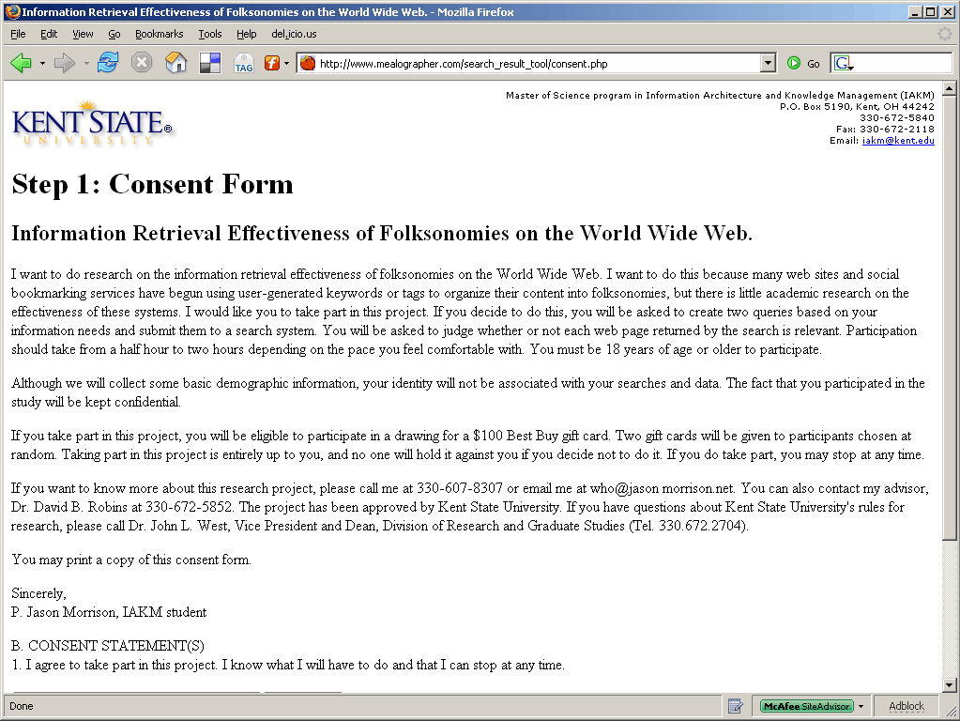
Consent form. Participants signed by typing their name and date in the field provided. They could elect to participate in the drawing by entering their email address. The participant's identifying information was not linked to data saved later by the testing interface.

Participants were guided through three search exercises by the test interface. This screen shot shows how participants were prompted to search for different types of information needs.

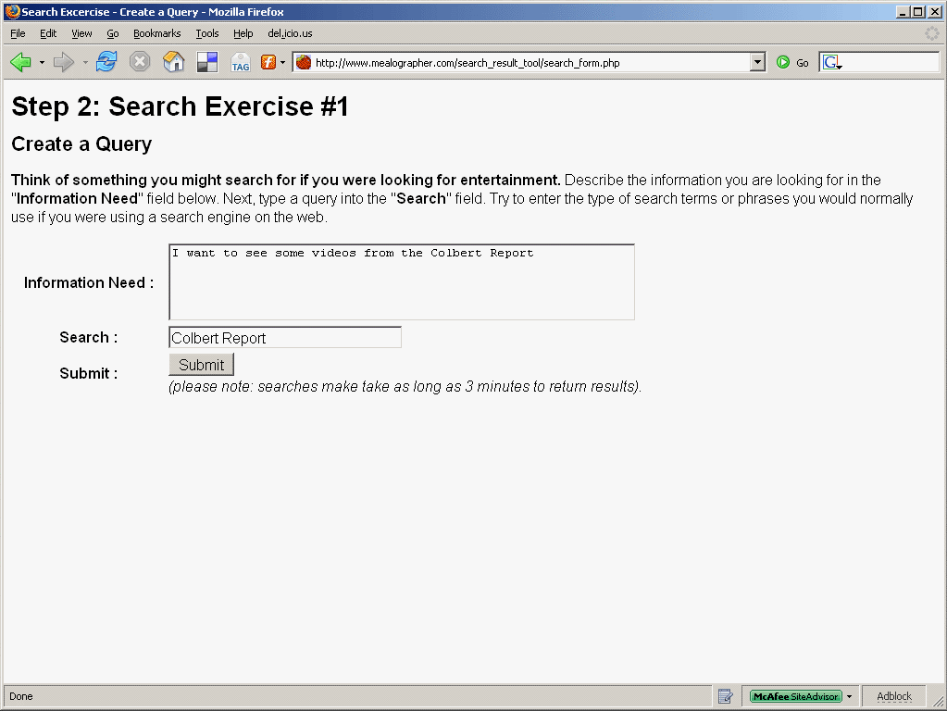
This is an example information need and query. The participants would then click the “Submit” button to continue.

While the test interface submitted queries and collated the results from the various IR systems, “Searching...” text was generated and periodically sent to the browser. This was done to avoid browser time out problems.

Results were presented randomly with the document title, description, and URL. The description was taken from the IR system's results if available. If no description was available, the test interface would read the document for a description meta tag. If no meta tag was found, the test interface would look for text within the first paragraph tag in the document. In some cases none of the above was found and the description was left blank. Participants were asked to check a checkbox if a particular item was relevant.
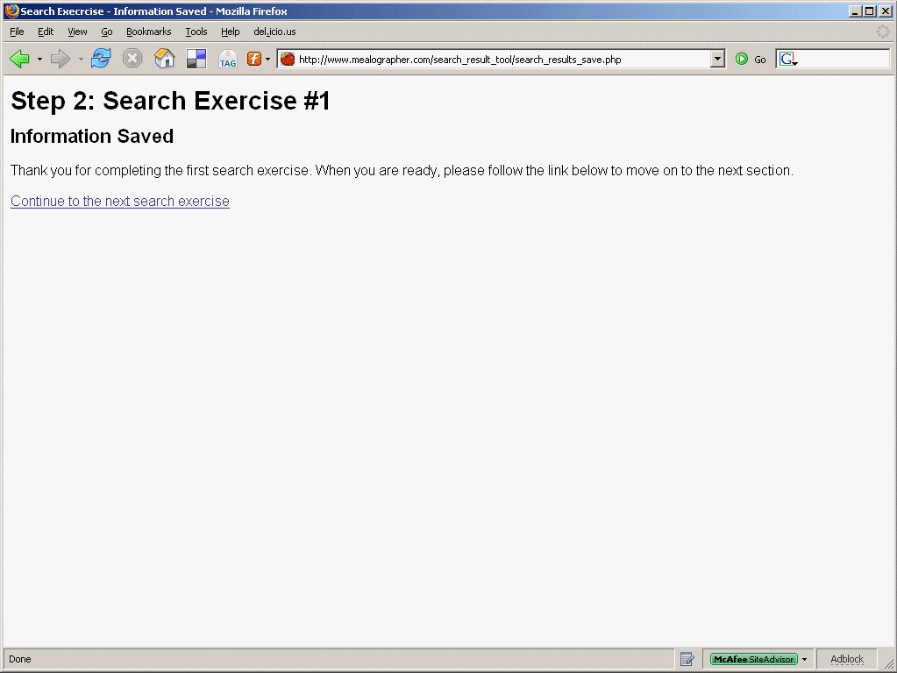
After each search exercise the test interface saved the results and prompted the participant to move on to the next step.

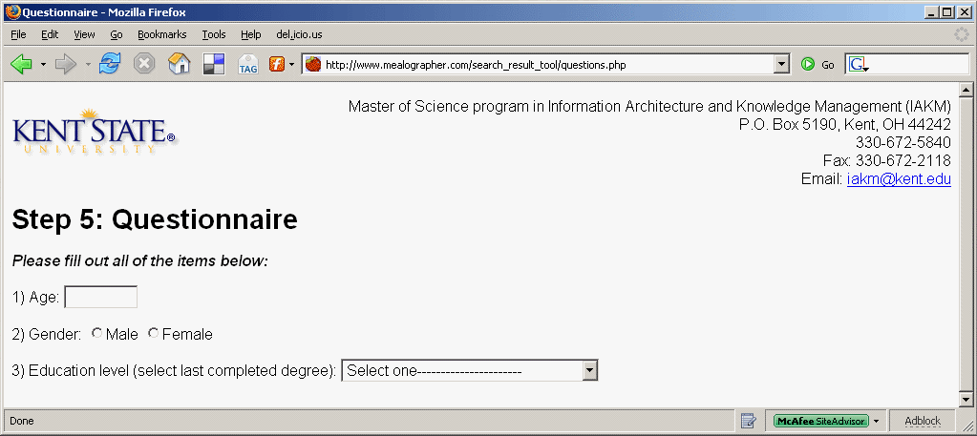
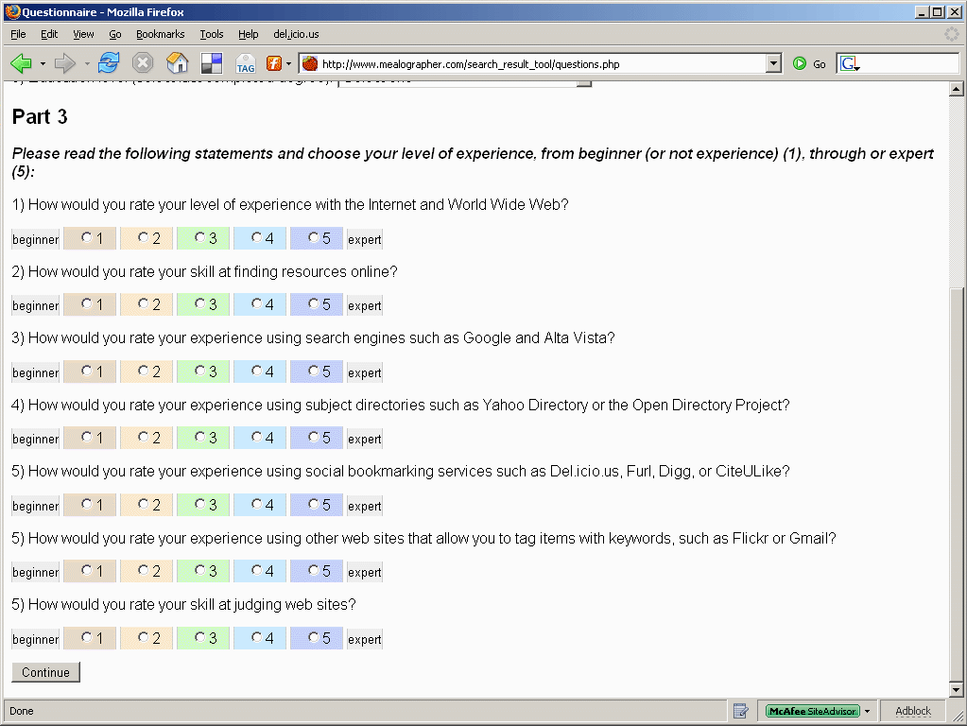
The questionnaire recorded basic demographic information and self-ratings of experience in areas relevant to the study.

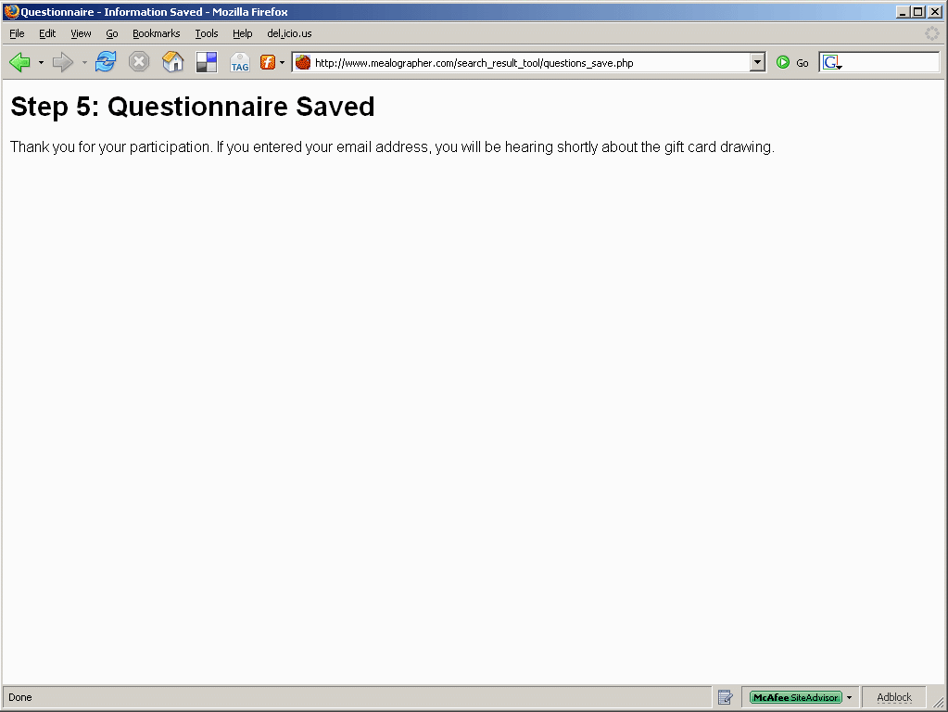
After the questionnaire was completed the test interface saved the results and thanked the participants.

Appendix B

Data Model Diagram

Appendix C

List of Participant Information Needs and Queries

Category | Information Need | Query
General | How can I convert Gas Mark 6 to Fahrenheit in a recipe? | gas mark 6 to fahrenheit
Entertainment | Is Moby playing in Cleveland soon? | moby tour schedule Cleveland, Ohio
General | Information about the show "Smallville" | Smallville
Factual | Which Meatpuppets songs were covered by Nirvana? | Nirvana Meatpuppets covers
Research | I am looking for information on studies that have examined the effect having a licensed library media specialist in a high school has on first high school academic achievement and later collegiate academic achievement. | academic achiev* high school librar* colleg*
Factual | In what city ism the national football hall of fame? | football hall of fame
Research | I would like to obtain information regarding the recording credits of drummer Jeff Porcaro. | Jeff Porcaro credit record
Factual | Who wrote the Monkee's Daydream Believer? | writer daydream believer
Exact Site | Homepage for the Cleveland Municipal School District. | cleveland municipal school district
Exact Site | I am want to find the contact information for someone with Project SAILS, a project sponsored by Kent State University. I want to find either an email address or phone number so I can ask a specific question. | contact Project SAILS
Research | I am looking for information about assessment of library instructors and what types of models are used to evaluate instructors. Some models include self-evaluation, peer-review evaluation, student evaluation, etc. | assessment library instructor
Factual | What are the hours of operation of Kent State University's main library? | hours kent state university library
General | I wanted information on how to enter VH1's show the World Series of Pop Culture. | World Series of Pop Culture
Factual | I need to know what date Hitler and the German army invaded Poland in WWII? | Hitler and the Germans invade Poland
News | I would like news information on the Mark Folley scandal on Capitol Hill, I'm not even sure how to spell his last name | Mark Folley
Exact Site | (My apologies for this being the third try here). I would like to find theaters and/or cinemas showing foreign films in the Akron area. | (theater or cinema) AND foreign AND (film or films) AND Akron
Research | I would like to find information on Gaelic-language periodicals published in North America. | Gaelic AND (magazine OR periodical OR journal) AND ("United States" OR Canada)
Factual | What is the third highest mountain in the world? | highest AND mountains AND world AND 3rd
News | Issues 3, 4, 5 -- Find out what they are really about. | Issue 3 or Issue 4 or Issue 5 & ohio
Exact Site | Find out about AP credit so I can advise my students. | AP Exam or Placement Exam or CEEB
Research | Find out how students can get credit for the AP exams at Kent State | AP Exam or Placement or CEEB
Research | Digital assest management systems for museums including publications, registrars, photography departments, that all include keyword, advance searching, wiki, OEI, and EAD compliance | digital asset management
General | Pinball parts for sale or pinball events | pinball
Exact Site | Ingalls Library new space Cleveland Museum of Art | Library Cleveland Museum of Art
Factual | What is the capitol of Montana | Montana capitol
News | issue #1 not on the ballot for the Novemeber 7 election in Cuyhoga County Ohio | Issue 1
News | What was the October death toll of American soldiers in Iraq? | Iraq War deaths American troops
General | I am looking for information about unicycles. | unicycle
Research | multimedia content and the semantic web | "multimedia content""semantic web"
News | Where the South Korean government should stand in the six party talk regarding the North Korean nuclear weapon testing. | "south korea""government""diplomacy""six party talk""north korea""nuclear program"
Exact Site | current events in the Korea Sustainable Development Network | event KSDN
Exact Site | Web page for Kent State's Financial Aid Office | Kent State Financial Aid Office
Research | I need to know some of the benefits of mentoring in the business environment for women. | Mentoring women and business
Entertainment | What time is Saw 3 playing in movie theaters in Kent? | Saw 3 showtimes Kent Ohio
News | I want information on the showtimes for the movie Borat. | showtimes 45248 borat
Entertainment | What band or bands is/are at the Blue Note on Saturday? | bluenote.com band schedule
Research | I need a list of some good tech books. Possibly some best of lists, etc. | amazon.com tech books best list
Research | Good recipes containing ground turkey and cooked in a crock pot/slow cooker | ground turkey recipies crockpot
News | Minister accused of paying for prostitution and purchasing methadone | minister meth
News | John Kerry makes joke about students and Iraq that was poorly received | kerry iraq students
News | I am looking for information on current issues on the ballot in Ohio in the upcoming. | "Issues" "upcoming election" "Ohio"
General | I am looking for information on when Season 2 of Stargate Atlantis will be released. | "season 2" "stargate atlantis" "DVD release"
Exact Site | I am looking for the webpage of Kent State University Library | "Kent State University Library"
Research | Texas administrative code relating to franchise tax | texas and administrative code and franchise tax
General | Curious about the evolution of Hallmark Ornament collecting | Hallmark and Gold Crown and Ornament
Exact Site | cuyahoga community college internal/external career opportunities | ccc and employment
News | I remember hearing about Elvis's teaddy bear being chewed up by a dog while the teddy was on display somewhere. I would like to know where this happened, the condition to the teddy now and if anything was done with the dog. | elvis teddy bear
Research | I am looking for general information on Asperger's Syndrome in adults. | asperger's syndrome adults
General | What movies has David Krumholtz apeared in? | David Krumholtz
General | I had chest pains, vomitting and sweating, but I really did not think it was a heart attack. I thought it was "heartburn from hell." After my ER visit, I wanted to see if these symptoms were typical of bad heartburn | heartburn, sweating, vomit
Exact Site | Want to find the website of DSCC. | DSCC
News | I want to view a sample election ballot for Delaware county Ohio, November 2006 elections | Delaware, OH and voting and ballot and 2006
Entertainment | A plan to repair the Hubble Space Telescope was announced. I want to know how much it will cost. | hubble AND repair AND cost
Research | I need a list of the elements used in PBCore metadata. | PBCore AND element AND list
News | I want to know who the MVP of the World Series was this year. | mvp AND "world series" AND 2006
News | Saddam's sentencing. | Saddam, sentence
General | The difference between issue 4 and issue 5 on Ohio's ballot. | issue 4, issue 5, ohio
Exact Site | How to nominate someone for the 2007 OLC Awards and Honors. | 2007 awards and Honors, olc
General | I wanted to compare the different library science programs | higher education library programs
Entertainment | Cedar Lee movie theatre- location and movie listing | "Cedar Lee
Factual | When did Anwar Sadat die? | Anwar Sadat
News | Names of firemen killed in CA wildfire | Wildfire, CA, fatalities
General | Lolita Fashion trends in Japan | Lolita, Japan, fashion
Factual | What is the geographic center of the state of OHio | Ohio, "Geographic Center"
Research | i want to find the locations of learning express toy stores | learning express locations
Exact Site | giant eagle in macedonia | giant eagle in macedonia
Exact Site | giant eagle macedonia | giant eagle macedonia
Research | Altarpieces painted for churches in Siena, Italy. | siena altarpiece madonna duomo
Exact Site | OCLC, Online Computer Library Center, Inc., Office of Research and Programs. | oclc research programs
News | Details on the Saddam Hussein death penalty verdict. | saddam hussein verdict
General | I need to do a biographical sketch about Louis Hennepin for my Rare books class. I was interested in biography and bibliography, and criticism. | Louis Hennepin
Exact Site | Does the Kent State Library Cataloging Department hire student workers? | Kent State Library Cataloging Student jobs
General | How many times does the Dude in the movie the Big Lebowski say the word "Man."? | Big Lebowski Trivia
Factual | Why is Julia Grant always pictured sitting sideways? | "julia grant" AND "pictures"
Exact Site | Lake Region State College | "Lake Region State College"
Entertainment | I would want to find a new mystery author. | mystery authors
Exact Site | I'm looking for the Borders Books and Music company website (my current employer) | Borders Books
Factual | what was the name of the first president of the united states of america? | first president united states
General | are there any star trek conventions in my area anytime soon? | star trek convention
News | Information on the cause of the NY Yankees plane crash | yankees plane crash cause
News | wanting more information on the recent spinach recall causing illnesses | spinach recall 2006
General | wondering what the conditions were for annulment | annulment conditions
Exact Site | I am looking for the Web site of my employer, Thomson/West. We create value-added research databases and print products that people in the legal profession use for their research | legal books and databases AND research solutions
News | I want to find the complete results of the 2006 Midterm United States Congressional election | midterm congressional election result for 2006
Factual | I want to find out how many planets there are in the solar system, according to the new definition of "planet". Answer=8 | number of planets in our solar system
Research | locating resources of all types for parents who homeschool their children | resources on homeschooling
News | want to find out the details of the evangelical minister's downfall from Colorado, Ted Haggard | Haggard resignation as evangelical minister
Research | need to find resources for teaching children to study poetry | resources on teaching children to study poetry
Exact Site | I am looking for a definition or description of knowledge management. | "Definition of Knowledge Management"
Entertainment | I want to read APA style research papers. | "APA style research papers"
Research | I am looking for the applications of knowledge management. | "Applications of Knowledge Management"
General | information about the church of scientology | scientology
General | What does the term dachshund mean in german | dachshund means in german
General | greek gods and their equivelent roman couterparts | greek and roman gods
Factual | Who were the overall male and female winners of the 2006 Akron Marathon? | 2006 Akron Marathon Winners
Entertainment | Upcoming Concerts held at Blossom Music Center | Blossom Music Center Schedule
Factual | Who was the 13th president of the united states? | 13th President of United States
News | Shiite and Suni religious differences and why they are pitted against each other and so violent towards each other in Iraq. | Shiite Suni religion history
News | family-life and political history of new house speaker (Democrat) Nancy Pelosi | Nancy Pelosi Democratic Speaker
Entertainment | Dates and movie listings for the upcoming (2007) Cleveland International FIlm Festival | Cleveland International Film Festival
Research | I have a sixth grade teacher with whom I am collaborating. Her students are completing a research project on Christmas Around the World. They need resources about holidays in different countries. | Chirstmas AND German*
Exact Site | I need to find the home page for the United Local School District. | United Local School District
Exact Site | I need to find the home page for United Local School District. | United Local School District

REFERENCES
Agarwal, Amit. (2006). Search Engine Index Sizes: Google vs Yahoo vs MSN. Digital Inspiration. Retrieved August 2, 2006 from http://labnol.blogspot.com/2006/07/search-engine-index-sizes-google-vs.html.

Al-Khalifa, H. S. and Davis, H. C. (2006). FOLKSONOMIES VERSUS AUTOMATIC KEYWORD EXTRACTION: AN EMPIRICAL STUDY. In Proceedings of IADIS Web Applications and Research 2006 (WAR2006). Retrieved January 20, 2007, from http://eprints.ecs.soton.ac.uk/12547/.

Beg, M. (2005). A subjective measure of web search quality. Information Sciences, 169(3-4), 365-381.

Bodoff, D. (2006). Relevance for browsing, relevance for searching. Journal of the American Society for Information Science and Technology, 57(1), 69-86.

Can, Fazli, Nuray, Rabia, and Sevdik, Ayisigi B. (2004). Automatic performance evaluation of Web search engines. Information Processing and Management, 40, 495–514.

Chau, Michael, Fang, Xiao, and Liu Sheng, Olivia R. (2005). Analysis of the query logs of a Web site search engine. Journal of the American Society for Information Science and Technology, 56(13), 1363-1376.

Chudnov, D, Barnett, J, Prasad, R and Wilcox, M. (2005). Experiments in academic social book marking with Unalog. Library Hi Tech.

Dye, Jessica. (2006, April). Folksonomy: A Game of High-tech (and High-stakes) Tag. EContent, Vol. 29 Issue 3, 38-43.

Eastman, Caroline M. and Jansen, Bernard J. (2003, October). Coverage, relevance, and ranking: The impact of query operators on Web search engine results. ACM Transactions on Information Systems (TOIS), Volume 21, Issue 4, 383 – 411.

Fichter, Darlene. (2006, May-June). Intranet Applications for Tagging and Folksonomies. Online, Vol. 30 Issue 3, 43-45.

Gordon, M and Pathak, P. (1999). Finding Information on the World Wide Web: The Retrieval Effectiveness of Search Engines. Information Processing and Management, 35, 141-180. Retrieved August 27, 2006 from http://www.cindoc.csic.es/cybermetrics/pdf/60.pdf.

Gordon-Murnane, Laura. (2006, June). Social Bookmarking, Folksonomies, and Web 2.0 Tools. Searcher, 14(6), 26-38.

Greisdorf, H., & Spink, A. (2001). Median measure: an approach to IR systems evaluation. Information Processing and Management, 37(6), 843-857

Guy, Marieke and Tonkin, Emma. (2006, January). Folksonomies: Tidying Up Tags? D-Lib Magazine. Volume 12, No. 1. Retrieved August 27, 2006, from http://www.dlib.org/dlib/january06/guy/01guy.html.

Hawking, D., Craswell, N., Bailey, P., Griffihs, K. (2001). Measuring Search Engine Quality. Information Retrieval, 4, 33-59. Kluwer Academic Publishers.

Hawking, David, and Robertson, Stephen. (2003, January). On Collection Size and Retrieval Effectiveness. Information Retrieval, v.6 n.1, 99-105.

Hull, D. (1993). Using statistical testing in the evaluation of retrieval experiments. ACM SIGIR 1993, Pittsburgh, PA.

Jansen, B. J., Spink, A., and Saracevic, T. (2000). Real life, real users, and real needs: a study and analysis of user queries on the web. Information Processing & Management, 36(2), 207–227.

Jansen, B., and Spink, A. (2006). How are we searching the World Wide Web? A comparison of nine search engine transaction logs. Information Processing and Management, 42(1), 248-263.

Kaser, D. (2003). Do You Yahoo!? Information Today, 20(4), 16.

Kerlinger, Fred N. and Lee, Howard B. (2000). Foundations of Behavioral Research. 4th Edition, Wadsworth / Thomson Learning.

Kobayashi, Mei and Takeda, Koichi. (June 2000). Information retrieval on the web. ACM Computing Surveys (CSUR) Volume 32, Issue 2 pp. 144 - 173

Leighton, H. V. and Srivastava, J. (1999). First 20 precision among world wide web search services (search engines). Journal of the American Society for Information Science, 50(10), 882–889.

Lucas, W. (2002). Form and function: The impact of query term and operator usage on Web search results. Journal of the American Society for Information Science and Technology, 53(2), 95-108.

Mizzaro, S. (1997). Relevance: The whole history. Journal of the American Society for Information Science, 48, 810–832.

Mowshowitz, A., and Kawaguchi, A. (2002). Assessing bias in search engines. Information Processing and Management, 35(2), 141–156.

Quint, B. (2002). 'Google: (v.)...'. Searcher, 10(2), 6.

Rosenfeld, Louis, and Morville, Peter. (2002). Information Architecture for the World Wide Web. Stebastopol, CA: O'Reilly.

Silverstein, C., Henzinger, M., Marais, H., and Moricz, M. (1999). Analysis of a very large web search engine query log. SIGIR Forum, 33(1):6–12. Previously available as Digital Systems Research Center TR 1998–014 at http://www.research.digital.com/SRC.

Spink, A., Dietmar, W., Jansen, B. J., & Saracevic, T. (2001). Searching the Web: the public and their queries. Journal of the American Society for Information Science and Technology, 52(3), 226–234.

Spink, A., Jansen, B., Blakely, C., and Koshman, S. (2006). A study of results overlap and uniqueness among major Web search engines. Information Processing and Management, 42(5), 1379-1391.

Sullivan, Danny. (2006). ComScore Media Metrix Search Engine Ratings. Search Engine Watch. Retrieved March 14, 2007, from http://searchenginewatch.com/showPage.html?page=2156431.

Vaughan, L. (2004). New measurements for search engine evaluation proposed and tested. Information Processing and Management, 40(4), 677-691.

Voorhees, E. (2000). Variations in relevance judgments and the measurement of retrieval effectiveness. Information Processing and Management, 36(5), 697-716.

